POTW Participation in CECs Studies
BACWA White Paper
DRAFT – February 2020

Contents
Background 1
Benefits of CECs Program Management through RMP 4
POTW Participation in RMP CECs Program 4
Identifying Representative Facilities for future studies 4
Case study – selecting a suite of representative POTWs to participate in CEC study 5
POTWs funding for RMP CECs Program 8
CEC Management in SF Bay – Next Steps 8
Appendix 1: POTW Location 10
Appendix 2: Population and Flows 11
Appendix 3: Treatment Technology 12
Appendix 4: Water sources 15
Appendix 5 – Special Study Proposal: Ethoxylated Surfactants in Ambient Water, Margin Sediment, and Wastewater 20

Background
The Regional Monitoring Program (RMP) forms the core of water quality, sediment quality, and tissue monitoring in the San Francisco Bay. Historically, each Publicly Owned Treatment Works (POTW) was responsible for performing receiving water monitoring as part of its individual NPDES Permit. The RMP was created in 1993 through Regional Board Resolution No. 92-043 that directed the Executive Officer to implement a Regional Monitoring Plan in collaboration with permitted dischargers pursuant to California Water Code, Sections 13267, 13383, 13268, and 13385. The goal was to replace individual receiving water monitoring requirements for dischargers with a comprehensive Regional Monitoring Program.
The Regional Monitoring Program’s specific objectives are to:
- Describe the distribution and trends of pollutant concentrations in the Estuary;
- Project future contaminant status and trends using best understanding of ecosystem processes and human activities;
- Describe sources, pathways, and loading of pollutants entering the Estuary;
- Measure pollution exposure and effects on selected parts of the Estuary ecosystem (including humans);
- Compare monitoring information to relevant benchmarks, such as total maximum daily load (TMDL) targets, tissue screening levels, water quality objectives, and sediment quality objectives; and
- Effectively communicate information from a range of sources to present a more complete picture of the sources, distribution, fate, and effects of pollutants and beneficial use attainment or impairment in the Estuary ecosystem.
The RMP has been investigating Contaminants of Emerging Concern (CECs) since 2001, and established a formal workgroup to address the issue in 2006. The RMP Emerging Contaminants Workgroup (ECWG) includes representatives from RMP stakeholder groups including POTWs, regional scientists, and an advisory panel of expert researchers that work together to address the Workgroup’s guiding management questions.
- Which CECs have the potential to adversely impact beneficial uses in San Francisco Bay?
- What are the sources, pathways and loadings leading to the presence of individual CECs or groups of CECs in the Bay?
- What are the physical, chemical, and biological processes that may affect the transport and fate of individual CECs or groups of CECs in the Bay?
- Have the concentrations of individual CECs or groups of CECs increased or decreased in the Bay?
- Are they predicted to increase or decrease in the future?
- What are the effects of management actions?
The overarching goal of the ECWG is to develop cost-effective strategies to identify and monitor CECs to support management actions to minimize impacts to the Bay. The ECWG guides an annual process of contaminant evaluation and long-term planning and optimization to respond to new RMP data and the rapidly evolving body of science on CECs.
Following this process for over a decade, the RMP has generated one of the world’s most comprehensive datasets for CECs in an estuarine ecosystem. While RMP stakeholders are the primary audience and user of RMP data and communications, the Program informs broader decision-making through outreach to state and federal agencies.
The RMP first published a formal CEC Strategy in 2013 as part of a continuous effort to refine approaches for supporting the management of CECs in San Francisco Bay. Periodic revision of the Strategy is essential given the rapid evolution of the science surrounding emerging contaminants; in 2017, the RMP completed its first revision of the RMP’s CEC Strategy, which was then updated in 2018.
For CECs known to occur in the Bay, the RMP prioritizes CECs using a tiered risk-based framework, as illustrated in Figure 1. This prioritization framework guides future monitoring proposals for each of these contaminants, the results of which, in turn, provide key data to update evaluations of potential risk. The criteria listed below are used for placement in each tier.

Figure 1. RMP’s Risk-based tiered framework
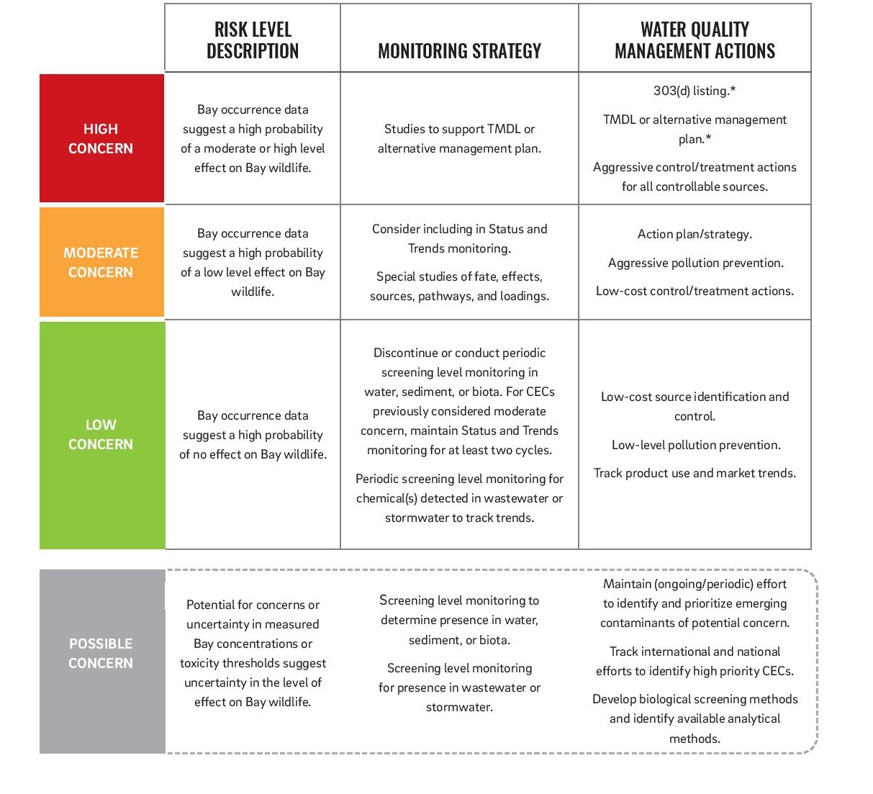
Up to date information, including the most recent CEC Strategy, can be found at the RMP’s Emerging Contaminants webpage.

Benefits of CECs Program Management through RMP
Different approaches have been discussed for monitoring CECs in aquatic ecosystems through the State of California, including requirements in individual NPDES permits, and a State-wide monitoring program. The San Francisco Bay Region is fortunate to have a mature and sustainable CECs program. Among the advantages of this program, over once where
- CEC science and strategy planning happens under one umbrella and is directed by scientists and stakeholders. There are not competing or duplicative studies.
- CECs monitoring is tailored to the specific questions that need to be answered in the SF Bay to maximize use of limited funds.
- Quality control for CECs monitoring data is managed by the RMP science team. In a system where dischargers directly input lab data into a database, this level of quality assurance is not present.

POTW Participation in RMP CECs Program
POTWs are a key pathway for some CECs to the SF Bay, including the CECs that are identified to be of “moderate” concern, such as fipronil, PFOS/PFOA, microplastics, and nonylphenols. Sampling of CECs in wastewater effluent has been a component of many of the studies conducted through the RMP. Past studies have looked at POTWs as sources of pharmaceuticals, pesticides, and more recently, microplastics. Over the previous decade, the need for effluent studies was identified by the RMP staff and ECWG, then a call was put out to POTWs to volunteer in these studies.
The Bay Area Clean Water Agencies (BACWA), a joint powers agency whose members own and operate POTWs throughout the SF Bay Region, has worked with the RMP to ensure that there was participation in these studies by the POTW community. Involvement in these studies has been on a volunteer basis. As the CECs program moves forward, there is interest in ensuring that the POTWs participating in these studies are representative of wastewater effluent quality from all POTWs, and studies do not just focus on the subset of agencies who repeatedly volunteer to participate.

Identifying Representative Facilities for future studies
It does not make sense to sample effluent at every POTW when a smaller number of representative POTWs can yield the information that is being sought in a particular study. One of the purposes of this White Paper is to provide information about BACWA’s member agencies that can be used to identify “representative” participants for future studies. The following characteristics were identified as pertinent because of their potential impacts on CECs in wastewater effluent. The information about each of the POTWs in the Region is included in the Appendices as listed below.
- Location by subembayment – Appendix 1
- Number of connections – Appendix 2
- Population served – Appendix 2
- Average dry weather flow treated – Appendix 2
- Discharge volume to Bay – Appendix 2
- Type of Treatment – Appendix 3
  - Secondary
  - Advanced Secondary/Filtration
  - Disinfection type
- Source water – surface vs. groundwater, potential agricultural impacts – Appendix 4

Industrial inputs to POTWs will also be important for some CECs. POTWs over 5 mgd maintain pretreatment programs whereby they regulate industrial users that contribute significant flow or federally regulated pollutants to the collection system. However, many CECs may be discharged from facilities that are not traditionally regulated, such as nursing homes, pet grooming facilities, hotels, and plant nurseries.
Keeping a comprehensive list of businesses that may be associated with CECs in each agency’s jurisdiction is not feasible, due to the changing identity and location of these businesses over time, and uncertainty in which CECs will be important in future studies. When an industrial use is associated with a CEC that is being studied, BACWA will work with the RMP to perform an online search for the businesses and industries of interest, then work to identify in which POTW’s jurisdiction or sewershed they operate. To help in this effort, BACWA is soliciting GIS shape files from its member agencies to develop a POTW “sewershed” map.
Some agencies have expressed concern that participating in CEC studies would lead to adverse impacts to their agencies, in terms of negative attention from regulators or the public. The Regional Water Board has made it clear that representative POTWs monitoring means the results will be considered characteristic of all POTWs of types similar to those monitored. Monitoring results will not be considered representative of just those POTWs that participated, and those POTWs will not be subject to any specific action(s) or regulatory consequence as a result of monitoring results.
To provide the State Water Board with the data it needs to avoid regulatory action on CEC monitoring, results from these studies will be entered into California Environmental Data Exchange Network (CEDEN) database. However, agencies that participate in the studies may request that they not be mentioned by name when the studies are described in articles submitted to scientific journals or in communications with the press.

Case study – selecting a suite of representative POTWs to participate in CEC study
To illustrate the process of selecting representative POTW, a case study is illustrated below. In the summer of 2019, the RMP conducted a study of ethoxylated surfactants (ES). The proposal for the study is provided in Appendix 5. The goal for POTW selection was to recruit a selection of POTWs with the following characteristics:
- Geographical diversity to help interpret observed surface water concentrations
- Diversity of treatment technologies to understand impact of treatment processes on ES compounds
- Facilities with higher flow rates to capture a significant portion of the total wastewater loading of ES compounds to the bay
In a literal sense, some of these criteria are mutually exclusive. For example, sampling at the EBDA outfall would allow capture of a greater portion of the loading to the Bay, but since the outfall discharge is made up of effluent from six different POTWs with different treatment trains, no information about individual treatment processes would be available from sampling at EBDA. Likewise, sampling at SFPUC’s Southeast Plant would have allowed capture of more of the total load to the SF Bay, but SFPUC uses the same secondary treatment technology, high purity oxygen activated sludge, and discharges to the same subembayment as EBMUD, so smaller facilities with different treatment technologies that discharge to different subembayments were selected.
The final selection of treatment facilities is presented in Table 1.
In the future, it is envisioned that the list of agencies participating in CECs studies will be maintained as a new appendix for this study. This will allow BACWA members, the Regional Water Board, and RMP staff to track participation over time, and provide a historical record of which agencies have participated and how they were selected.

Table 1. POTW sampling design for ethoxylated surfactants.
 | Facility | Annual Average Daily Effluent Flows (mgd) | Subembayment | Secondary | Tertiary Treatment | Nitrification | Denitrification | Disinfection
1 | San Jose-Santa Clara | 87 | LSB | Activated Sludge/Biological Nutrient Removal | Y | Y | Y | Liquid Chorine
2 | Palo Alto | 18.4 | LSB | Trickling Filter/Nitrifying Activated Sludge | Y | Y |  | UV
3 | Hayward | (discharge through EBDA outfall) | SB | Trickling Filter/Solids Contact |  |  |  | Sodium Hypochlorite
4 | EBMUD | 52.5 | CB | High Purity Oxygen Activated Sludge |  |  |  | Sodium Hypochlorite
5 | CCCSD | 35.4 | Suisun Bay | Activated Sludge with Anaerobic Selector |  |  |  | UV
6 | Fairfield Suisun | 13.4 | Suisun Bay | Oxidation Tower/Activated Sludge | Y | Y |  | UV
7 | Vallejo | 9.2 | San Pablo Bay | Trickling Filter/Activated Sludge |  | Y (partial) |  | Liquid Chlorine
8 | San Mateo | 10.4 | SB | Activated Sludge |  |  |  | Sodium Hypochlorite

POTWs funding for RMP CECs Program
The RMP participants, including dredgers, stormwater agencies, and municipal and industrial dischargers that hold Water Board permits for waste discharge into the Estuary, fund the RMP as a requirement of their permits. Each year a portion of this funding was allocated to CECs studies, but by 2016, as overall RMP funding was decreasing due to diminishing contribution from the dredgers, an alternative source of funding was sought.
In 2015, BACWA worked with the SF Regional Water Board to review the costs and benefits of the routine monitoring required by agencies’ individual NPDES permits, and concluded that significant resources were being spent on monitoring for pollutants that were rarely detected. BACWA and the SF Regional Water Board reached an agreement to reallocate resources from low-value effluent testing to the RMP. The strategy reflects the need to shift our effort from contaminants that were of concern historically, largely due to industries that are no longer located in the region, to emerging priorities. In April 2016, the Regional Water Board adopted order R2-2016-0008, which establishes opt-in Alternative Monitoring and Reporting Requirements for municipal NPDES permittee, and which can raise a maximum of $289K per year for RMP studies.
Because of the limited funding available to the RMP for CECs studies, POTW effluent monitoring is not included in some RMP studies where it is a lower priority than monitoring other matrices. In the past, individual POTW have volunteered to fund effluent monitoring for studies that are managed by RMP staff. A recent example of this approach is the 2017 Screening of Pharmaceuticals in San Francisco Bay Wastewater Study. Because relying on agency volunteers to fund these special studies puts an unfair burden on those agencies who step up, when agencies throughout the Region benefit, beginning in FY21 BACWA is considering providing a budget derived from member dues for POTW-specific CEC studies led by the RMP. Descriptions of POTW funded studies will be included as an appendix in future updates to this White Paper.

CEC Management in SF Bay – Next Steps
As described in the Tiered Risk Framework, CECs in the “moderate” tier are subject to management plans and pollution prevention. While BACWA welcomes information about removal efficacy for CECs through different wastewater treatment trains, we view pollutant prevention as the most important strategy for reducing CEC loading to receiving waters.
BACWA’s Bay Area Pollution Prevention Group (BAPPG) funds public outreach, and professional outreach and training for both traditional pollutants such as Fats, Oils, and Grease, mercury, and copper, as well emerging contaminants such as pharmaceuticals. In Fiscal Year 2021, microplastics and PFAS will be added to the list of prioritized pollutants. BAPPG’s public facing website, baywise.org, contains public outreach materials that can be used by member and partner agencies.
In addition to public outreach, BAPPG also supports regulatory advocacy for pollutants such as pesticides, including fipronil. POTWs don’t have direct authority to regulate pesticides in their service area. However, over the past few years, BAPPG has partnered with the SF Regional Water Board to comment on EPA’s pesticide reregistrations, to urge them to consider pathways to the sewer when doing risk assessments. More information about BAPPG’s Pollution Prevention activities can be found in their 2018 Annual Report.
DTSC’s Safer Consumer Products initiative is another pathway to address the use of CECs of moderate or higher concern. DTSC maintains this program to identify and develop a regulatory response for chemicals, formulations, or products that may pose a human health or ecological risk.
Finally, POTWs, either individually or through BAPPG, CASA, or other associations, support legislation to control products leading to CEC pollution. Support of pharmaceutical take-back programs is an example of effective advocacy in the past.
The RMP’s CEC Program has been key to our understanding of emerging concerns in the San Francisco Bay. Moving into the future, the CEC program through the RMP will continue to inform BACWA’s pollution prevention efforts, and BACWA is committed to its continued support.

Appendix 1: POTW Location

Figure A1. POTW Location by subembayment
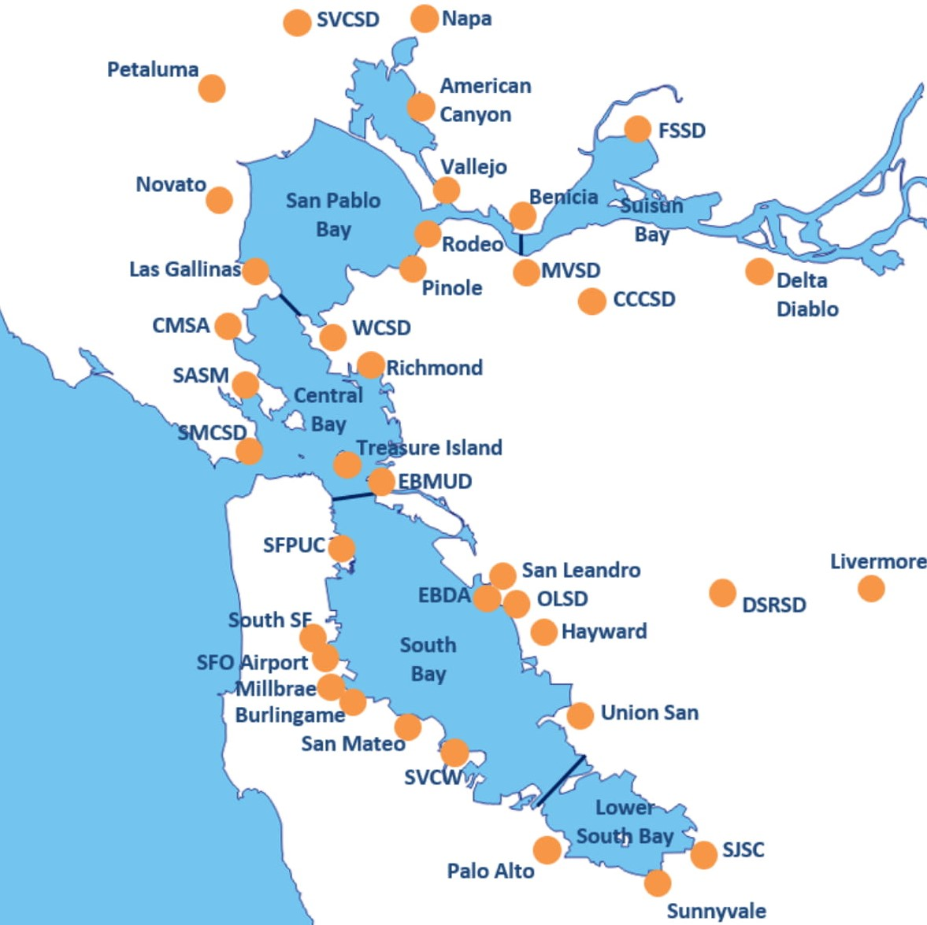

Appendix 2: Population and Flows

Table A2: Population and flows
 | # connections served (2014) | Estimated Population | 2014 ADWF (mgd) | 2017/18 Flow to Bay
American Canyon | 5,562 | 16,800 | 1.2 | 1.4
Benicia | 9,569 | 28,000 | 2 | 2
Burlingame | 1,600 | 37,000 | 2.7 | 2.8
CCCSD | 115,109 | 500,000 | 33.8 | 35.4
CMSA | 52,161 | 105,000 | 4.7 | 9.3
Delta Diablo | 57,700 | 200,000 | 12.5
DSRSD | 53,509 |  | 9.2 | 9.6
EBDAª |  |  |  | 59.7
EBMUD | 160,000 | 685,000 | 49 | 52.5
FSSD | 38,800 | 140,000 | 11.8 | 13.4
Haywardª | 32,000 | 153,000 | 11.1
Las Gallinas | 15,800 | 30,000 | 2.1 | 1.4
Livermore | 29,500 | 83,600 | 6.7
Millbrae | 6,550 | 22,000 | 1.6 | 1.5
Mt. View SD | 10,500 | 21,900 | 1.2 | 1.3
Napa SD | 36,000 | 82,700 | 12.6 | 4.6
Novato SD | 28,700 | 60,000 | 4.1 | 3
Oro Loma SDª | 47,000 | 126,000 | 12
Palo Alto |  | 220,000 | 18 | 18.4
Petaluma | 25,300 |  | ? | 3.2
Pinole | 11,215 | 40,000 | 2.8 | 2.5
Richmond ^{b} | 20,000 |  | 6
Rodeo | 2,967 | 8,900 | 0.4 | 0.6
San Jose | 483,667 | 1,400,000 | 76 | 87
San Leandroª | 15,300 | 60,000 | 4.86
San Mateo | 37,823 | 155,000 | 10.3 | 10.4
Sewerage Agency of Southern Marin | 14,800 | 29,500 | 2.8 | 2.3
SFO | n/a | n/a | 1.1 | 1.2
SFPUC | 450,000 | 580,000 | 58 | 57.4
Sausalito Marin City Sanitary district | 6,500 | 10,756 | 1.3 | 1.2
SSF |  | 110,500 | 8.4 | 7.6
Sunnyvale | 28,314 | 148,000 | 12.9 | 10.6
Sonoma | 17,200 | 36,000 | 3 | 0
Silicon Valley Clean Water |  | 199,000 | 13.7 | 14
Treasure Island |  | 2,900 |  | 0.3
Union Sanitary Districtª | 111,184 | 347,000 | 22
Vallejo | 37,845 | 117,000 | 9 | 9.2
West County WD ^{b} | 32,300 | 100,000 | 8
West County Agency ^{b} |  |  |  | 9.8
ªEBDA provides the outfall to the SF Bay for the City of Hayward, Oro Loma Sanitary District, the City of San Leandro, and Union Sanitary District.
^{b}West County Agency provides the outfall to the SF Bay for the City of Richmond and West County Wastewater District.

Appendix 3: Treatment Technology
Treatment technology can impact the removal of CECs through wastewater treatment by biodegradation and partitioning to solids. Disinfection technology will impact the formation of disinfection byproducts. Table 3 shows the treatment technologies used at each POTW.

Table A3. Treatment Technologies.
AS = Activated Sludge; TF = Trickling Filter; BNR = Biological Nutrient Removal; MBR = Biological Membrane Reactor
 | Secondary Treatment Type | Disinfection Type | Advanced secondary/filtration (y/n)
American Canyon | MBR | UV | y
Benicia | AS and Rotating Biological Contactor (RBC) | Liquid Chlorine | n
Burlingame | AS | Sodium Hypochlorite | n
CCCSD | AS | UV | n
CMSA | TF/AS | Liquid Chlorine | n
Delta Diablo | TF/Solids contact | Sodium Hypochlorite | n
DSRSD | AS | Liquid Chlorine | n
EBMUD | High Purity Oxygen | Sodium Hypochlorite | n
FSSD | Oxidation Towers/AS | UV | y
Hayward | TF/Solids contact | Sodium Hypochlorite | n
Las Gallinas | Rock TF, nitrification TF, deep bed granular filter | Liquid Chlorine | n
Livermore | AS | Sodium Hypochlorite | n
Millbrae | AS | Sodium Hypochlorite | n
Mt. View SD | TF, nitrification biotower | UV | y
Napa SD | AS | Sodium Hypochlorite | n
Novato SD | AS | UV | n
Oro Loma SD | AS | Sodium Hypochlorite | n
Palo Alto | TF/AS | UV | y
Petaluma | AS/BNR | UV/Sodium Hypochlorite | n
Pinole | AS | Liquid Chlorine | n
Richmond | AS | Sodium Hypochlorite | n
Rodeo | AS | Sodium Hypochlorite | n
San Jose | AS/BNR | Liquid Chlorine | y
San Leandro | TF/AS | Sodium Hypochlorite | n
San Mateoª | AS | Sodium Hypochlorite | n
Sewerage Agency of Southern Marin | TF | Liquid Chlorine | n
SFO | AS | Liquid Chlorine | n
SFPUC | High Purity Oxygen | Sodium Hypochlorite | n
Sausalito Marin City Sanitary district | TF | Liquid Chlorine | n
SSF | AS | Liquid Chlorine | n
Sunnyvale | TF/DAF/Dual Media Filtration | Chlorine Gas | y
Sonoma | AS | Chlorine Gas | n
Silicon Valley Clean Water | TF/AS | Liquid Chlorine | n
Treasure Island | TF | Sodium Hypochlorite | n
Union Sanitary District | AS | Sodium Hypochlorite | n
Vallejo | TF/Solids Contact | Liquid Chlorine | n
West County WD | AS | Sodium Hypochlorite | n
ª San Mateo is in the process of an upgrade to BNR/MBR

Appendix 4: Water sources
There are six major water wholesalers and large retailers serving residents in the service area of Bay area POTWs:
- Contra Costa Water District (CCWD) - CCWD’s primary source of water supply is the United States Bureau of Reclamation’s Central Valley Project (CVP).
- East Bay Municipal Utilities District (EBMUD) - EBMUD delivers water from the Mokelumne River watershed, supplemented with water from East Bay watershed reservoirs. Water from the EBMUD is not expected to include groundwater, or be influenced by agricultural drainage.
- SFPUC Region Water System (RWS) – The SFPUC delivers water imported from the Hetch Hetchy reservoir, as well as reservoirs in the Alameda Watershed and Peninsula Watershed. Beginning in 2017, SFPUC began accessing local groundwater supplies. Water from the SFPUC is not expected to be influenced by agricultural drainage.
- Santa Clara Valley Water District – SCVWD – Sources of supply for the District include natural groundwater recharge, local surface water, imported surface water from the State Water Project (SWP) and CVP, and transfers. Imported water from the SWP and CVP is expected to have some impact from agricultural drainage at its source in the SF Delta.
- Sonoma County Water Agency (SCWA) – The Russian River provides most of the Water Agency’s water supply with groundwater supply from the Santa Rosa Plain as a secondary source. Water from the Russian River is expected to have some impact from agricultural drainage.
- Zone 7 –The SWP is Zone 7’s largest water supply, and is supplemented by local surface water and groundwater. Imported water from the SWP and CVP is expected to have some impact from agricultural drainage at its source in the SF Delta.

Information about the water supplies in the sewersheds of each POTW is presented in the Water Agencies’ Urban Water Management Plans (UWMP), which are available on DWR’s website. The POTWs for each Water Agency are reported in Table 6.3 of each UWMP. For each POTW, Table x identifies the Water Agencies supplying their service area, the agencies’ water sources, and whether there may be an agricultural influence on the source water supply, or if groundwater is a significant supply source. Most areas are served by smaller retailers who provide a combination of water purchased from wholesalers, and local surface or groundwater.

Table A4: Source Water Supplies

WW Agencies | Water Agency | Sources | Groundwater supply (y/n) | Potential Agricultural Impacts (y/n)
American Canyon | American Canyon City Of | SWP, City of Vallejo (see below) | n | y
Benicia | City of Benicia | SWP, Sacramento River, Solano Project (Lake Baryessa), local surface water | n | y
Burlingame | Hillsborough Town Of | SFPUC RWS | n | n
 | Burlingame City Of | SFPUC RWS | n | n
CCCSD | Martinez City Of | CCWD | n | y
 | Contra Costa Water District | Central Valley Project, other Delta supplies | n | y
 | East Bay Municipal Utility District | Mokelumne Watershed, local surface water | n | n
CMSA | Marin Municipal Water District | Local surface water | n | n
Delta Diablo | Contra Costa Water District | Central Valley Project, other Delta supplies | n | y
 | Antioch City Of | Delta, and Contra Costa Canal (CCWD) | n | y
 | Pittsburg City Of | CCWD, and local groundwater | y | y
 | Golden State Water Company - Bay Point | CCWD, and local groundwater | y | y
DSRSD | Zone 7 | State Water Project, Local surface Water, Local Groundwater, Imported Surface Water from Byron-Bethany Irrigation District | y | y
 | Pleasanton City Of | Zone 7, and local groundwater | y | y
 | Dublin San Ramon Services District | Zone 7 | y | y
 | East Bay Municipal Utility District | Mokelumne Watershed, local surface water | n | n
EBMUD | East Bay Municipal Utility District | Mokelumne Watershed, local surface water | n | n
Fairfield-Suisun Sewer District (FSSD) | Suisun - Solano Water Authority | SWP, Solano Project (Lake Barryessa) | n | y
Hayward | Hayward City Of | SFPUC RWS | n* | n
LGVSD | Marin Municipal Water District | Local surface water | n | n
Livermore | Zone 7 | State Water Project, Local surface Water, Local Groundwater, Imported Surface Water from Byron-Bethany Irrigation District | y | y
 | California Water Service Company Livermore | Zone 7 (SWP), and local groundwater | y | y
 | Livermore City Of | Zone 7 | y | y
 | Pleasanton City Of | Zone 7, and local groundwater | y | y
Millbrae | Millbrae City Of | SFPUC RWS | n | n
Mt. View Sanitary District | Contra Costa Water District | Central Valley Project, other Delta supplies | n | y
 | Martinez City Of | CCWD | n | y
Napa Sanitation District | American Canyon City Of | State Water Project, City of Vallejo (see below) | n | y
 | Napa City Of | SWP, local surface water | n | y
Novato Sanitary District | North Marin Water District | SCWA, local surface water | y | y*
Oro Loma Sanitary District | East Bay Municipal Utility District | Mokelumne Watershed, local surface water | n | n
Palo Alto | California Water Service Company Los Altos/Suburban | SCVWD (State Water Project, Central Valley Project), Local Groundwater | y | y
 | California Water Service Company Mid-Peninsula | SFPUC RWS | n | n
 | East Palo Alto City Of | SFPUC RWS | n | n
 | Mountain View City Of | SFPUC RWS, SCVWD, and local groundwater | y | y
Petaluma | City of Petaluma | SCWA, local groundwater | y | y
Pinole/Hercules | East Bay Municipal Utility District | Mokelumne Watershed, local surface water | n | n
Richmond | East Bay Municipal Utility District | Mokelumne Watershed, local surface water | n | n
Rodeo Sanitary District | East Bay Municipal Utility District | Mokelumne Watershed, local surface water | n | n
San Jose | Milpitas City Of | SFPUC RWS, and SCVWD (CVP and SWP, not GW) | n | y
 | San Jose City Of | SFPUC RWS, SCVWD (surface), and local groundwater | y | y
 | San Jose Water Company | SCVWD, and local groundwater | y | y
 | Santa Clara City Of | SFPUC RWS, SCVWD (surface), and local groundwater | y | y
 | Great Oaks Water Company Incorporated | Local groundwater | y | n
San Leandro | East Bay Municipal Utility District | Mokelumne Watershed, local surface water | n | n
San Mateo | California Water Service Company Mid-Peninsula | SFPUC RWS | n | n
 | Hillsborough Town Of | SFPUC RWS | n | n
Sanitary District No. 5 (Tiburon) | Marin Municipal Water District | Local surface water | n | n
 | SCWA | Russian River | n | y
Sewerage Agency of Southern Marin | Marin Municipal Water District | Local surface water | n | n
 | SCWA | Russian River | n | y
Sausalito-Marin City Sanitary District | Marin Municipal Water District | Local surface water | n | n
 | SCWA | Russian River | n | y
SFPUC | San Francisco Public Utilities Commission | SFPUC RWS (Hetch Hetchy, and local surface water, local groundwater) | y | n
SFO | SFO | SFPUC RWS | n | n
Silicon Valley Clean Water | California Water Service Company Bear Gulch | SFPUC RWS, local surface | n | n
 | East Palo Alto City Of | SFPUC RWS | n | n
 | Menlo Park City Of | SFPUC RWS | n | n
 | Mid-Peninsula Water District | SFPUC RWS | n | n
Sonoma | Sonoma County Water Agency (SCWA) | Russian River, local groundwater | y | y
South San Francisco and San Bruno | California Water Service Company South San Francisco | SFPUC RWS, and local groundwater | y | n
Sunnyvale | California Water Service Company Los Altos/Suburban | SCVWD (State Water Project, Central Valley Project), Local Groundwater | y | y
 | Sunnyvale City Of | SFPUC RWS, SCVWD (surface), and local groundwater | y | y
Treasure Island | Treasure Island Water System | SFPUC RWS | n | n
Union Sanitary District | Alameda County Water District | SWP, SFPUC RWS, local groundwater | y | y
Vallejo Sanitation & Flood Control District (VFCSD) | Vallejo City Of | SWP, Solano Project (Lake Barryessa), local surface water | n | y
West County Wastewater District | East Bay Municipal Utility District | Mokelumne Watershed, local surface water | n | n

Appendix 5 – Special Study Proposal: Ethoxylated Surfactants in Ambient Water, Margin Sediment, and Wastewater

https://www.sfei.org/programs/sf-bay-regional-monitoring-program#tab-1-4
See full report: https://www.sfei.org/sites/default/files/biblio_files/BACWA%20Pharmaceutical%20Report_103018.pdf
https://bacwa.org/document/bappg-2018-annual-report/
https://dtsc.ca.gov/scp/safer-consumer-products-program-overview/
https://wuedata.water.ca.gov/uwmp_plans.asp

