Treatment Wetlands for nutrient removal from Bay area wastewater Facilities
Screening Level Opportunities and Constraints Analysis
June 2017

Treatment Wetlands for Nutrient Removal from Bay Area Wastewater Facilities: A Screening Level Opportunities and Constraints Analysis, June 2017

Prepared by Ian Wren
GIS analysis by Micha Solomon (San Francisco Estuary Institute)
Input and document review provided David Senn and Philip Trowbridge (San Francisco Estuary Institute) and members of the San Francisco Bay Nutrient Management Strategy Steering Committee

Cover images courtesy of Oro Loma Sanitation District and recently implemented treatment wetlands

This work was funded by the San Francisco Bay Nutrient Management Strategy

Table of Contents
Executive summary 2
Introduction 3
Approach 3
Introduction to Nutrient Removal via Free Water Surface Wetlands 5
Treatment Wetlands in California: An Overview 8
Results: Potential Utility of Treatment Wetlands in the Bay Area 11
Opportunities and Constraints of Treatment Wetlands & Integrated Planning 22
Recommended Approach for Integrated Regional Planning 26
References 28
Appendix A: Land Conversion Suitability Screening 29
Appendix B: 2012-2016 Average Seasonal POTW Flows and Total Nitrogen Loads 31
Appendix C: Facility-Specific Results (Reduction Potential & Estimated Cost) 33
Appendix D: Wetlands-Related Regulations 38

Executive summary
This report summarizes a scoping-level analysis regarding the utilization of free water surface (FWS) wetlands for wastewater treatment under several nutrient concentration reduction scenarios in the San Francisco Bay region. Scenarios analyzed include three (3) total Nitrogen (TN) reduction strategies (15 mg L⁻¹, 6 mg L⁻¹ and 3 mg L⁻¹) as well as two (2) types of treatment wetlands: 1) shallow unvegetated basins with nitrate removal efficiencies based on demonstration studies conducted at the Town of Discovery Bay, CA wastewater treatment plant, and 2) typical vegetated FWS wetlands based on literature values for nitrate reduction.
This analysis involved the estimation of potentially suitable land area for conversion to treatment wetlands within a two-mile radius of wastewater sources; calculation of TN removal requirements for each Permittee of the 2014 San Francisco Bay Nutrient Watershed Permit¹; and comparison of TN removal rates potentially achievable via utilization of the two treatment wetland types identified versus that required to meet each of the three TN concentration reduction scenarios. Cost estimates were also provided, based on literature values, though actual values are site specific and can vary widely from suburban regions with access to unutilized land versus urban areas with multiple environmental and land use conflicts.
Based on land constraints alone, 13 of the 34 wastewater facilities subject to the Nutrient Watershed Permit could meet a hypothetical 15 mg L⁻¹ TN standard and 7 could meet a 3 mg L⁻¹ effluent limitation for TN. This assumes full utilization of potentially available lands in proximity to a given facility and nitrification of wastewater effluent prior to discharge. Assuming all facilities are acting individually to meet TN reduction scenarios, the acreages presented below could achieve corresponding rates of TN reduction, which are substantially less than the reductions needed to fully satisfy the three TN reduction scenarios.
 | Level 2 (15 mg L⁻¹) | Level 3 (6 mg L⁻¹) | Advanced (3 mg L⁻¹)
Sum of potentially available area of vegetated FWS treatment wetlands available to meet scenario (region-wide) | 2,100 ac | 4,500 ac | 6,400 ac
Region-wide TN reduction potential, assuming implementation of FWS wetland acreage provided above | 29% | 41% | 45%
Estimated TN reduction if the same acreage was used entirely for Discovery Bay-like systems | 47% | 58% | 59%
Region-wide TN reductions needed to meet scenario | 58% | 83% | 92%
Average present value cost per pound nitrate removed | $1.27 | $2.75 | $2.54
As suggested above, diminishing rates of TN reduction is observed despite significant addition of acreage, due to the uneven availability of sites potentially suitable for conversion to treatment wetlands. On a regional scale, this analysis suggests a reasonable rate of TN load reduction achievable through treatment wetlands FWS is 40-50%. Higher reduction requirements would necessitate optimization and upgrades of facilities and or other multi-benefit solutions, such as wastewater recycling and nutrient recovery. Treatment wetlands show great promise for helping achieve potential nutrient reduction needs, in addition to ancillary benefits, at substantially less cost compared with grey-infrastructure based technologies.
Further analysis is needed to refine land acquisition/utilization potential in the vicinity of wastewater sources, identify most appropriate treatment wetland designs and generate site-specific cost estimates. Additional recommendations include development of consistent permitting rules; identification of desired outcomes for multi-benefit treatment wetlands; development of an appropriate subembayment-scale nutrient credit trading structure; and a conceptual strategy for addressing technical, financial and outreach-based requirements for deploying a regional-scale program for multi-benefit treatment wetlands.

INTRODUCTION
Wastewater infrastructure throughout the Bay Area is approaching an age where large scale master planning efforts are underway to consider modernization efforts in a manner that increases production of recycled water, reduces nutrient discharges and addresses sea level rise-induced flood risk. In addition, publicly owned treatment works (POTWs) are being asked to consider alternatives to reduce nutrient loading to San Francisco Bay. The 2014 Nutrient Watershed Permit asks the thirty-four (34) Permittees to consider not only grey infrastructure treatment-based options, but also the use of green infrastructure and wastewater recycling.¹ Other green infrastructure-based approaches to nutrient reduction include landscape or agricultural irrigation, streamflow augmentation, horizontal subsurface flow (HSSF) or vertical flow (VF) wetlands. Compared with the latter two options, FWS wetlands are more ubiquitous and generally considered most appropriate for large-scale treatment applications, due to cost and space considerations. Though natural treatment systems have incorporated combinations of various technologies, based on individual needs.

Purpose
The purpose of this study was to conduct a scoping-level assessment of treatment wetlands at each of the POTWs subject to the Watershed Nutrient Permit. Specific objectives were to estimate the size of wetlands needed for each POTW to meet planning level nutrient criteria, compared to space constraints within a two-mile radius, and to provide literature-based cost estimates. Additional information includes an overview of complementary and conflicting planning efforts, regulatory summary and recommendations for advancing regional strategies for treatment wetlands and multi-benefit water projects.

Approach
Discussions surrounding use of treatment wetlands for Bay Area POTWs include the multiple challenges associated with permitting, conflicting restoration priorities and perceptions regarding use of baylands for wastewater treatment. For the purposes of this scoping analysis, these considerations are largely ignored, to inform whether physical conditions exist to facilitate the construction or enhancement of areas within a 2-mile radius of the Nutrient Watershed permittees for FWS facilities. And if so, to what degree could natural treatment systems meet the treatment benchmarks established for the Optimization and Upgrade analyses currently underway by HDR, on behalf of the Bay Area Clean Water Agencies (BACWA).
This analysis is not entirely divorced from reality though – recognizing that certain areas are more suitable for conversion to tertiary/polishing wetlands than others. Table 1 summarizes the ranking system established for conducting the GIS-based screening exercise. Appendix A describes the screening procedure more fully. Lands were excluded if characterized as open bay, developed lands or tidal marsh habitat, which serve as proxies for Waters of the U.S. or the existing urban landscape. Such areas encompass a majority of the space in proximity to most wastewater sources in the Bay Area.
Table 1. Habitat/land use ranking for purposes of identifying areas potentially suitable for FWS installations
Rank | Example Habitat Types
Unsuitable | intact tidal marsh, existing developed lands, open bay, South Bay Salt Pond Restoration Project
Low | diked marsh, lagoons, managed marsh (i.e. visibly degraded wetlands)
Medium | urban open space, former military lands, inactive salt ponds (i.e. salt ponds not currently scheduled for restoration and underutilized open space)
High | existing storage and treatment ponds, farmed and ruderal baylands
Remaining areas were classified as Low, Medium and High, in terms of opportunity for conversion to FWS facilities or other natural treatment systems. These factors roughly reflect regulatory, physical and economic constraints. Other factors for exclusion included relative elevation to the wastewater source and existing slope.
For the purposes of identifying a modeling approach and determining which literature-based data sources should be relied upon, stakeholder feedback indicated a strong interest in utilizing locally-derived nutrient treatment performance data. Monitoring data collected at existing treatment wetlands is available, from Mt. View Sanitation District and Hayward Marsh for instance, the latter of which receives secondary treated effluent from Union Sanitary District. Additionally, detailed examination of nitrate removal performance from a FWS at the Town of Discovery Bay’s POTW was the subject of a UC Berkeley PhD dissertation and publication in 2014. Data from the Discovery Bay system and average wetland treatment performance values largely informed this analysis.^{2,3}

Assumptions:
Assumptions relied upon for this exercise include:
- FWS sizing and removal efficiencies estimated based on dry weather flows and loading rates, obtained from BACWA’s 2016 Group Annual Report, which details average flows and loads from 2012 to 2016.⁴ A summary of average flown and TN loads from each of the Permittees is included in Appendix B (2012-2016 Average Seasonal POTW Flows and Total Nitrogen Loads). This assumes nutrient enrichment is of highest concern during warmer months, when conditions are more conducive to algal blooms and suppressed dissolved oxygen. This also takes into account the non-trivial space requirements for treatment wetlands, suggesting wetland treatment should be catered to address those loads of highest concern.
- Removal efficiency estimates based on models for reduction of nitrate.^{2,3} As a result, this analysis assumes full conversion of TN to nitrate. Nitrification prior to discharge represents additional costs not considered here, which would generally apply to Permittees outside of the North Bay and Lower South Bay, where dry weather discharge prohibitions and/or ammonia reduction standards already apply. Benefits of nitrification prior to discharge include ammonia toxicity reduction, which could aid in permitting and mosquito control, as well as enhanced removal efficiencies from FWS systems for nitrate, compared with ammonia.
- Estimated available wetland area, as determined by GIS analysis, was reduced by 40% to account for patch sizes too small or isolated for practical use and/or incomplete free water surface.
- Average dry weather water temperature estimated as 21˚C. This is based on conditions reported through the California Integrated Water Quality System (CIWQS) by Union Sanitary District from the treatment wetlands at Hayward Marsh. From this data, average dry weather (Apr - Sep) temperature from 2011 – 2016 was 21˚C and average wet weather (Oct - Mar) temperature was 15˚C (Figure 1). This is slightly cooler than average temperatures observed at Discovery Bay (23˚C), yet is considered more representative of most Bay Area POTWs, based on location.
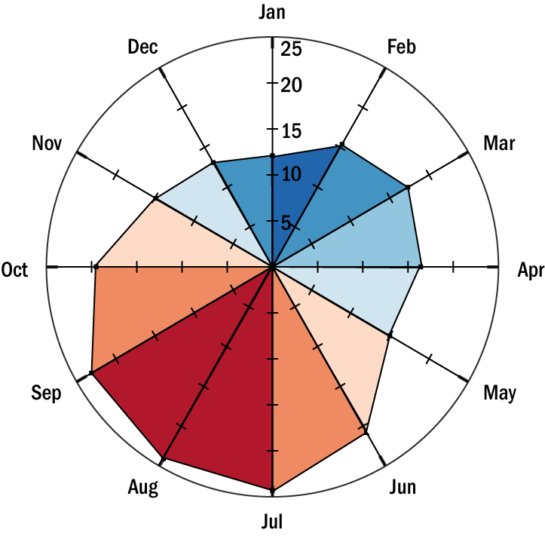
Figure 1. Average Monthly Water Temperature in Hayward Marsh (2011-’16):

- Soil permeability of the most restrictive soil layer assumed to be too low (e.g. <0.15 cm/hr) to prove suitable for infiltration-based treatment processes. This is given the proximity to the Bay and restrictive clay soils for most facilities. Site-specific analysis, outside the scope of this effort, may prove some sites suitable for infiltration-based systems.

Introduction to nutrient removal via free water surface wetlands
Use of treatment wetlands for wastewater treatment has been used for centuries and is supported by a robust body of knowledge to understand the science of treatment wetland processes and engineering strategies.^{5,6} For several decades surface and sub-surface wetlands have been used around the world for tertiary treatment or wastewater effluent ‘polishing’. The most common class of natural treatment systems for wastewater discharges in the US are FWS systems given high performance and the relatively low cost of construction, operation and maintenance.
This analysis is confined to consideration of FWS applications, though site specific application of sub-surface approaches to wastewater treatment may be appropriate. Novel approaches to green infrastructure-based strategies for wastewater treatment, notably ecotone levees, are being evaluated in the region and show promise for meeting multiple benefits, yet treatment performance data is not available to inform site-specific analysis.

Optimized open water systems vs. vegetated FWS wetlands for nitrate removal
Research performed in the region by Reinventing the Nation's Urban Water Infrastructure (ReNUWIt), a UC Berkeley/Stanford collaboration, prompted a rethinking of traditionally held views regarding wetland treatment processes and function. The group found that optimized shallow basins achieve higher removal of wastewater-borne pollutants in California’s warm California than traditional vegetated FWS systems. This research suggests opportunities for optimizing treatment wetland complexes for wastewater treatment and ancillary benefits, as well as utilizing small footprint areas once considered too isolated or urban for green infrastructure-based approaches to wastewater treatment.

Recent literature indicated unvegetated systems are poorly suited for denitrification, compared to wetlands with soft emergent vegetation. The literature indicates vegetated systems are favored over unvegetated basins in part due to nutrient uptake associated with plant growth, as well as other functions critical to nutrient transformation, including carbon supply and microbial attachment sites.⁴
Research performed at a demonstration project in Discovery Bay, as well as earlier work at the Prado Wetlands along the Santa Ana River in Riverside County, indicates this may not be the case, under optimized conditions - including those that promote warmer water temperatures and biomat formation.
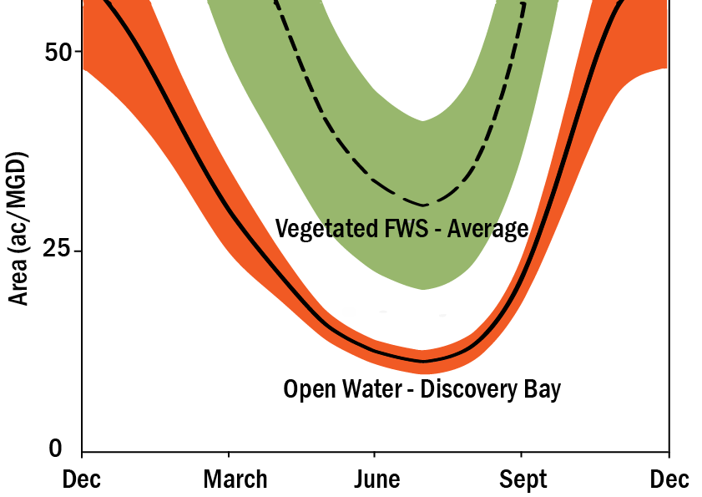
Figure 2. Estimated acreage to achieve 90% NO3 removal of nitrate from 1 MGD of effluent from the shallow basins at Discovery Bay versus typical FWS treatment wetlands²

Unvegetated open water were not believed to promote denitrification, with observed rate constants about one third of those for vegetated systems. This may be a due to factors of climate, microbial community or engineering, though until recently fully vegetated marshes with either emergent or submergent communities were recommended to optimize denitrification rates.⁵ Work carried out locally at the Discovery Bay POTW and in Southern California at the Prado Wetlands found that shallow unvegetated open water systems could actually result in greater nitrate removal rates than the majority of surface-flow vegetated treatment wetlands.²
Rapid denitrification was observed within biomats of the shallow (0.3 m) pilot project at the Discovery Bay POTW, which nitrifies its effluent prior to discharge, at rates far exceeding those observed at traditional vegetated FWS treatment wetlands (Figure 3). Refer to Appendix C for discussion of removal rates and equations used to generate Figure 3. The discrepancy between the Discovery Bay project and earlier studies may be due to the presence of shallow basins in a warm climate, whereas earlier studies of unvegetated open water systems were deeper and did not favor establishment of thick biomats (i.e. 4-8 cm) with thriving denitrifying bacteria communities.
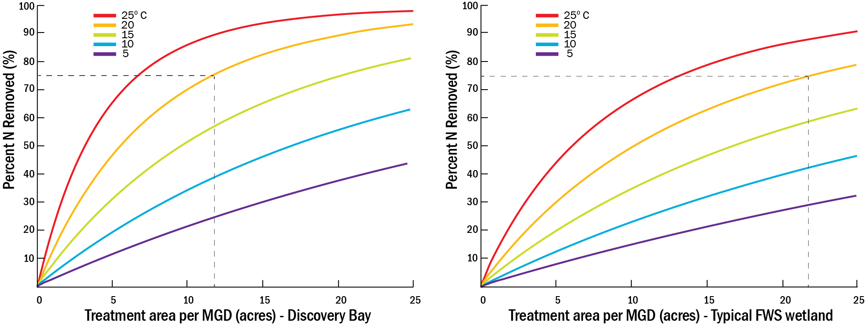
Figure 3. Nitrate removal performance in optimized shallow basins at Discovery Bay versus average performance of vegetated FWS treatment wetlands
Regardless of the cause of this difference in treatment performance, the Discovery Bay site indicates the potential for high rates of removal for nitrate and other contaminants, with smaller area requirements compared to the majority of free-water surface flow vegetated treatment wetlands. This led to the conclusion that wetland operators could convert portions of existing vegetated wetlands to shallow, open-water wetlands to enhance removal of trace organic contaminants (e.g., pharmaceuticals and personal care products) via photolysis and aerobic biotransformation, as well as pathogens via photoinactivation, without sacrificing nitrate removal. The system also found rapid accretion rates associated with biomat formation, suggesting such systems could aid in sea level rise adaptation in low lying areas proximal to the Bay. A similar system is currently being piloted at the Silicon Valley Advanced Water Purification Center to assess pollutant removal effectiveness from reverse osmosis concentrate.
Careful design and maintenance is required to establish and maintain conditions suitable for biomat formation and associated denitrification.² Recommendations include:
- Lining of shallow cell(s) to prevent the growth of emergent macrophytes;
- Shallow water (<30 cm deep) and low linear flow rates (∼0.1 cm s−1) to ensure a diffuse biomat on the wetland bottom receives sufficient sunlight to support photosynthesis; and
- Occasional harvesting of the biomat is needed to prevent clogging and discourage macrophyte growth.
Given the high maintenance needs of such optimized shallow, open water systems, vegetated systems may be preferred where ample area is available. Additionally, given the limited habitat function of such heavily managed systems, mitigation requirements may be imposed by resource agencies, effectively requiring restoration or creation of equal or greater wetland area than would be required of a vegetated system. Appropriately designed vegetated systems, or hybrid approaches involving unvegetated shallow basins, may be capable of serving as ‘self-mitigating’ systems – providing sufficient habitat value that compensatory mitigation is not required.

Design Considerations for Nitrate Removal
In contrast to detention/retention ponds designed for reduction of particulate-based pollution, higher detention time does not necessarily correlate well to nitrogen removal. Higher removal can be achieved where longer detention is facilitated by more wetland area at a fixed, shallow, depth. Yet deeper water does not achieve additional sediment surface area where anoxic zones favor denitrification. Rate coefficients are unaffected by increasing depth and vegetated wetlands designed mainly for nitrate removal should feature shallow vegetated benches where denitrification is maximized in sediments and in submerged biofilms on the base of emergent plants.³ The intent should be to maximize the rate coefficient (K) through enhancing temperature with shallow depth (i.e. ~ 0.3 m).
As described in Kadlek (2011), in instances where modest concentration reductions are required (i.e. <50%) high rates of hydraulic efficiency are not necessary, which is reflected in the N parameter in the tanks in series model (refer to Appendix C). As higher concentration reductions are required, N becomes a more sensitive parameter and the use of serpentine channels or cells in series, separated by baffles can enhance removal. Removal rates within the individual cells can be optimized by (a) increasing aspect ratio, (b) providing cross-cell water distribution and collection (i.e. enhanced mixing), and (c) using banded vegetation patterns within the cell rather than fringing vegetation around the cell perimeter.⁸

Ancillary benefits of treatment wetlands
Where deemed feasible, treatment wetlands offer a number of additional benefits beyond those represented by traditional grey infrastructure-based treatment systems. In some instances, treatment wetlands will be considered infeasible, particularly where land is scarce or cost-prohibitive. Where considered feasible, however, wetlands should be considered as a means to achieve a number of other benefits:
- Flood risk mitigation (dry weather treatment wetlands could also serve as wet weather detention)
- Contaminant removal (i.e. heavy metals, pesticides, suspended sediments and contaminants of emerging concern (CECs))
- Enhanced habitat extent and value
- Recreation (e.g. bird watching, hiking, fishing)
- Greenhouse gas sequestration and reduced heat island effect
When considering funding sources for natural treatment systems involving grants or other public sources, efforts should be made to quantify the full suite of environmentally beneficial outcomes associated with a project.

Ancillary consequences of treatment wetlands
Certain habitat and aesthetic benefits are diminished in highly engineered systems, where vegetation is limited or managed to maximize removal efficiencies and/or discourage mosquito populations. FWS wetlands operate most efficiently as shallow, low vegetation systems, thus diminishing aesthetic and habitat values. Where available space is available, project proponents may choose to utilize vegetated FWS systems over shallow unvegetated basins, for maintenance purposes or to enhance ancillary aesthetic and habitat-related benefits.
Regardless of the type of system utilized, California’s climate and public health regulations necessitate a mosquito abatement program, including use of mosquitofish or other control system. Ammonia toxicity under such conditions is a concern, thus generally requiring nitrification prior to discharge. Treatment wetlands are used for ammonia removal, though additional design requirements are required to achieve nitrification and denitrification and toxicity concerns may diminish feasibility. Horizontal sub-surface flow HSSF wetlands could be designed in a manner that would not necessitate nitrification, though such systems are generally most applicable at lower flow rates.⁵
A more thorough understanding of ammonia toxicity requirements and mosquito control is warranted. Hayward Marsh, for example, currently receives un-nitrified secondary effluent from Union Sanitary District at rates approximating 50 mg L⁻¹, according to self-reported data.⁹ Reporting data suggests some nitrification/ denitrification, particularly in summer months, though the role of dilution versus denitrification is difficult to parse out in this example since Bay water enters the treatment pond area. Regulators may choose to evaluate brackish treatment wetlands to reduce the need for nitrification and mosquito control, though additional assessment regarding ammonia toxicity and assimilation in receiving waters is required.

Treatment Wetlands in california: an overview
Treatment wetlands are used extensively throughout the world to achieve varying levels of treatment performance, ranging from primary to tertiary/polishing of effluent prior to discharge. California is well suited for FWS-type treatment facilities, though application of such systems is limited, likely due to high land costs and limited regulatory requirements or incentives to upgrade beyond traditional secondary treatment. This section summarizes the established treatment wetland facilities in the Bay Area and elsewhere around California.

Treatment wetlands in the Bay Area
Bay Area sanitation districts were some of the first along the West Coast to adopt treatment wetlands into their treatment trains. Based on review of available information, Mt. View Sanitation District was the first on the West Coast to adopt natural treatment, starting as a pilot project in 1974 and adopted as a permanent feature in 1977. Since then, Las Gallinas, Fairfield-Suisun Sewer District (FSSD), Sonoma Valley County Sanitation District (SVCSD), Union Sanitary and Petaluma have formally integrated wetlands into their treatment processes. Others have incorporated wetlands into their treatment process as demonstration projects, including Oro Loma Sanitation District and the Palo Alto Regional Water Quality Control Plant. For some of these examples, detailed case studies are compiled in EPA reports or through a recently prepared report by the SF Bay Regional Water Quality Control Board.^{10, 11}
To help facilitate the permitting of these projects, the San Francisco Water Quality Control Board (SF Bay RWQCB) adopted Resolution No. 94-086, in 1994, to transparently grant exceptions to applicable Water Quality Control Plan waste discharge prohibitions regarding shallow discharges. Resolution No. 94-086 requires dischargers to demonstrate a net environmental benefit will be derived as a result of the discharge. The SF Bay RWQCB recognizes the Resolution should be updated to address sea level rise adaptation and incorporate lessons learned from existing projects. In a recent report, SF Bay RWQCB staff recommends updates to Resolution No. 94-086 with a list of minimum required elements that must be included in a marsh management plan including sea level rise planning, participation in regional monitoring efforts, and adaptive management.¹¹

Table 2. Summary of the six permanent or pilot treatment wetlands currently operating in the Bay Area
Location | discharge type | Summary
Las Gallinas Valley SD | permanent discharges to wetland and agriculture | Las Gallinas Valley Sanitary District employs a reclamation projects consisting of 200 ac irrigated pasture, 40 acres (ac) of storage ponds, a 20 ac freshwater wetland, 10 ac salt marsh and landscape irrigation to eliminate dry weather discharges. This project has been active since 1984.
Ellis Creek Water Recycling Facility, Petaluma | permanent discharges to wetlands adjacent to tidally-influenced portion of the Petaluma River | ~4.5 million gallons per day (MGD) of dry weather flows routed to treatment wetlands, beginning in 2009. Flow is routed from 146 ac oxidation ponds to 16 ac constructed wetlands. Water is then chlorinated then routed to 31 ac of polishing wetlands or a chlorine contact chamber. Dechlorinated water discharged to Petaluma River of recycled for irrigation. Nutrient removal data from the wetlands is not available.
Moorhen Marsh; Mt. View SD | permanent discharges to treatment wetlands | 1.3 MGD dry weather flow routed to treatment wetland, prior to release to Suisun Bay, representing 100% of total flow from the facility. Nitrified effluent (~30 mg L⁻¹ NO₃) is discharged to the wetland and removal effectiveness ranges from 13% in winter months to 50% in summer months (~30% annual average). Ponds A & B came on line as a pilot project in 1974. Ponds C, D & E came on line in 1977.
Oro Loma SD | pilot/demonstration discharges to horizontal levee | The Oro Loma Sanitary District Wet Weather Equalization and Ecotone Demonstration Project involves studying the application of treated wastewater to create upland ecotone habitats for tertiary treatment and sea level rise adaptation. Project remains in construction phase though testing of treatment performance for constructed wetlands is in progress.
Union Sanitary | on-going discharges to Hayward Marsh | ~2.6 MGD routed to three 145 ac freshwater marsh basins and two 60 ac brackish basins. NPDES permit was obtained in 1983 and effluent was supplied to Hayward Marsh starting in 1988. Ponds are in need of maintenance and future use as a treatment wetland is uncertain.
Palo Alto | long-term demonstration project involving discharges to Matadero Creek via Renzel Marsh | Nitrified effluent discharged to Renzel Marsh prior to discharge to Matadero Creek, beginning in 1994. Wetland complex comprised of 15 ac freshwater marsh and Data from 2013-14 indicates Renzel Marsh is capable of reducing marsh influent TN concentrations by 40% via denitrification and cellular uptake (based on 0.74 MGD flow). Phosphorus is reduced by only 4%. Phase II study involved 1.26 MGD, where TN removal reduced to 30%.¹²
Fairfield | on-going discharges of advanced secondary effluent to Boynton Slough (Suisun Marsh) | FSSD discharges ~14 MGD of advanced secondary effluent to Boynton Slough, part of the larger Suisun Marsh complex. Approximately 10-15% of FSSD effluent recycled for agricultural and landscape irrigation.
Napa-Sonoma Marsh | on-going discharges to Schell Slough, two managed wetlands and Napa-Sonoma Marsh | SVCSD discharges tertiary-treated effluent during the wet season to Schell Slough during time of reduced demand for recycled water. Water is discharges to two managed wetlands during the dry season to maintain freshwater marshlands and ponds. Future discharges may occur to aid is restoration of 9,460 ac of saline ponds in Sonoma Marsh.

Other California Facilities
Permitting and oversight of treatment wetlands in California is generally carried out at the regional level, since California does not have a set of uniform regulations governing the design, siting and monitoring of such systems. Several well established systems in California are summarized in Table 3.
Table 3. Summary of other wastewater treatment wetlands in CA
Location |  | discharge type | Summary
City of Arcata |  | permanent discharges to surface wetland for secondary treatment | A design flow of 2.3 MGD routed to a 7.5 ac treatment wetland (2 ft depth/1.9 day retention time) for secondary treatment, followed by discharge to 31 ac of ‘enhancement marshes’ (1.5 ft depth/9 day retention time).
City of Riverside |  | permanent discharges to surface wetland for nitrogen removal | 10 MGD of flow historically routed through ~50 ac of streatment wetlands/ponds, referred to as the Hidden Valley Wetlands. Since early-1990s formally used to achieve nutrient removal. Effort underway to re-establish flow after maintenance failure.
City of Riverside |  | permanent discharges of river water receiving urban runoff and municipal effluent | Up to 100 ft³/s from the Santa Ana River routed to the 465 ac Prado Basin Wetland. Removes ~20 ton NO₃-N per month since 1992 and can achieve 90% removal in summer months.
City of Stockton |  | permanent discharges to ponds/surface wetland for secondary treatment | Average flow of ~30 MGD routed to 135 ac of treatment wetlands for secondary treatment, followed by treatment in ‘nitrifying biotowers’ during winter months to achieve NPDES requirements for ammonia. Oxidation ponds, prior to treatment wetlands, achieve ammonia removal in summer months
City of Davis |  | permanent discharges to ponds/surface wetland for tertiary treatment | Treating an average dry weather flow of 7.5 MGD, the system uses ponds (120 ac/5 ft depth/40 day retention in dry weather) and overland flow, to a 170 ac field, for secondary treatment and treatment wetlands for polishing.
As green infrastructure plays a greater role in the management of wastewater, stormwater and reverse osmosis concentrate, regulators may consider a consistent approach to the permitting and oversight of treatment wetlands. Other states, such as Florida and Louisiana, where wetlands play a greater role in wastewater treatment and assimilation, maintain transparent permitting processes governing the design, maintenance and monitoring of such systems. California’s size and geographic diversity may require region-specific strategies for natural treatment. The San Francisco Bay region conceived such a strategy, with respect to municipal stormwater management in 1994, with adoption of Resolution No. 94-107 (Policy on the Use of Constructed Wetlands for Urban Runoff Pollution Control). ¹³ This preliminary policy was intended as a ‘test case for later regional or statewide policies’, which are still in the process of development.

results: potential utility of Treatment Wetlands in the bay area

Nutrient loading rates for the thirty-four (34) permittees of the Watershed Nutrient Permit were derived from average dry weather values presented in BACWA’s 2016 Annual Nutrient Report.⁴
Average daily dry weather flows and average daily TN loading, based on data collected between 2012 and 2016 formed the basis of determining TN load reduction requirements, under three concentration reduction scenarios (Table 5). Level 2 and 3 values are consistent with scenarios used in HDR’s Optimization and Upgrade study, whereas the Advanced scenario has been adopted elsewhere to meet stringent nutrient reduction targets.¹⁴
Table 4. Summary of the three concentration reduction scenarios considered for this analysis
scenario | TN Concentration (mg L⁻¹)
Level 2 | 15.0
Level 3 | 6.0
Advanced | 3.0
Steps involved in this analysis included:
Figure 4. Average dry season TN loads from Bay Area POTWs
- GIS-based assessment of area potentially available for conversion to treatment wetlands, within a two-mile radius of a wastewater source, according to the ranking system summarized in Table 1;
- Calculation of concentration reduction requirements for each Permittee, based on annual reporting data;
- Estimation of load reduction potential, were the lands identified in Step 1 utilized for treatment wetlands, compared against the reductions required for the concentration reduction scenarios; and
- Estimated cost (capital and present value) for construction of treatment wetlands at each Permittee.
A summary of average flow and loading rates for each POTW used for this analysis is presented in Appendix B. This data reflects dry weather discharge prohibitions for some North Bay dischargers and ammonia controls for Lower South Bay facilities, resulting in wide variations in nutrient removal efficiency, TN loading and treatment configuration.

Potentially available land in proximity to a wastewater source
Using available data sources related to land use, habitat type and elevation, areas within a two-mile radius were ranked, in terms of potential suitability for conversion to treatment wetlands (Table 4).

Table 5. GIS-based estimates of area potentially available for conversion to treatment wetlands within a two-mile radius of a wastewater source, according to suitability ranking (Low, Medium, High)
Permittee/Wastewater source | Acres Available, According to Opportunity Ranking
 | LOW | Medium | High | SUM
American Canyon | 53 | 173 | 171 | 397
Benicia | 22 | 0 | 32 | 53
Burlingame | 23 | 0 | 31 | 55
Central Contra Costa Sanitary District | 158 | 0 | 242 | 401
Central Marin Sanitation Agency | 81 | 0 | 71 | 152
Port Costa Wastewater Treatment Plant | 0 | 0 | 10 | 10
Delta Diablo | 66 | 0 | 38 | 104
East Bay Dischargers Authority (sum) | 559 | 692 | 4,504 | 5,755
- Hayward | 152 | 33 | 366 | 550
- San Leandro | 214 | 0 | 224 | 439
- Oro Loma | 67 | 0 | 299 | 366
- Union Sanitary District | 127 | 0 | 310 | 437
- Livermore-Amador Valley | 0 | 251 | 1,588 | 1,840
- Dublin San Ramon | 0 | 157 | 127 | 284
- Livermore | 0 | 251 | 1,588 | 1,839
East Bay Municipal Utility District | 0 | 0 | 0 | 0
Fairfield-Suisun | 850 | 0 | 874 | 1,725
Las Gallinas Valley | 57 | 0 | 582 | 638
Marin County (Paradise Cove) | 0 | 0 | 0 | 0
Marin County (Tiburon) | 0 | 0 | 0 | 0
Millbrae | 89 | 0 | 23 | 112
Mt. View | 265 | 0 | 470 | 735
Napa | 99 | 10 | 578 | 687
Novato | 52 | 189 | 517 | 758
Palo Alto | 44 | 0 | 109 | 153
Petaluma | 168 | 0 | 544 | 712
Pinole | 0 | 0 | 7 | 7
Rodeo Sanitary District | 3 | 0 | 15 | 19
San Francisco International Airport | 80 | 0 | 29 | 109
San Francisco (Southeast Plant) | 2 | 0 | 142 | 144
San Jose/Santa Clara | 606 | 518 | 759 | 1,883
San Mateo | 4 | 0 | 25 | 29
Sausalito-Marin City | 0 | 0 | 1 | 1
Sewerage Agency of Southern Marin | 0 | 0 | 0 | 0
Sonoma Valley | 10 | 0 | 357 | 368
Silicon Valley Clean Water | 3 | 1 | 31 | 34
South San Francisco and San Bruno | 73 | 0 | 37 | 110
Sunnyvale | 218 | 0 | 148 | 367
Treasure Island | 0 | 0 | 0 | 0
Vallejo | 0 | 0 | 34 | 34
West County and City of Richmond | 25 | 0 | 96 | 121

This ranking exercise serves in part to indicate the level of regulatory burden and potential impacts to Waters of the U.S. associated with creation of treatment wetlands at each location. Intact marsh and open water represent the largest categories within 2-mile of Bay Area POTWs, and were excluded from consideration (Figure 5). Low ranking lands include severely degraded wetland habitat that may be considered Waters of the U.S., yet likely require significant regulatory hurdles and mitigation. High ranking lands are considered most suitable for conversion and include un- or under-utilized uplands with relatively few environmental conflicts, such as wetland designations or known habitat for sensitive or listed species.
An example of the distribution of potentially available lands for three East Bay Discharger Authority (EBDA) facilities is reflected in Figure 6. These POTWs hold some of the greatest promise, in terms of ability to achieve TN reductions, accompanied with other ancillary benefits.
This exercise serves to highlight obvious distinctions between more urbanized and land-constrained facilities of the Central Bay (e.g. EBMUD and SFPUC) versus facilities in suburban areas with potentially greater access to land (e.g. Fairfield-Suisun and Livermore-Amador Valley). Areas of particular opportunity include those located either adjacent to open space lands or in close proximity to degraded baylands areas suitable for restoration or enhancement.
Site specific analysis and wetland/habitat surveys are required to better establish suitability. This analysis also does not consider land ownership and other practical constraints likely to play a greater factor in terms of identifying land available for conversion to treatment wetlands.
Figure 5. Proportion of land within a 2-mile radius of a wastewater source within each sub-embayment, by suitability ranking

Figure 6. Ranking of potential treatment wetland sites in a 2-mile radius of three EBDA facilities

TN reductions needed to achieve concentration reduction scenarios
Based on average TN and flow data from 2012 to 2016, concentration reduction requirements to meet the potential scenarios are presented in Table 6. These scenarios correspond to those utilized for optimization and upgrade analyses being conducted by HDR, Inc., on behalf of BACWA, as well as an advanced reduction scenario consistent with objectives seen in other regions (refer to Table 4).
Table 6. 2012-2016 average dry-season TN loads, concentrations and corresponding reductions to meet loading scenarios
Discharger | AvG Load (kg D⁻¹) | Avg Conc.  (mg L⁻¹) | % Reduction Needed for Level 2 | % Reduction Needed for Level 3 | % Reduction Needed for Advanced
American Canyon | 54 | 11.9 | 0% | 50% | 75%
Benicia | 219 | 30.4 | 51% | 80% | 90%
Burlingame | 364 | 37.0 | 59% | 84% | 92%
Central Contra Costa Sanitary District | 3,880 | 32.2 | 53% | 81% | 91%
Central Marin Sanitation Agency | 946 | 47.2 | 68% | 87% | 94%
Port Costa | 0 | N/A | N/A | N/A | N/A
Delta Diablo | 1,320 | 58.1 | 74% | 90% | 95%
East Bay Dischargers Authority | 7,953 | 39.5 | 62% | 85% | 92%
East Bay Municipal Utility District | 10,115 | 56.1 | 73% | 89% | 95%
Fairfield-Suisun | 1,085 | 28.1 | 47% | 79% | 89%
Las Gallinas Valley | 0 | N/A | N/A | N/A | N/A
Marin County (Paradise Cove) | 2 | 42.7 | 65% | 86% | 93%
Marin County (Tiburon) | 60 | 31.7 | 53% | 81% | 91%
Millbrae | 272 | 55.3 | 73% | 89% | 95%
Mt. View | 113 | 24.9 | 40% | 76% | 88%
Napa | 14 | 12.3 | 0% | 51% | 76%
Novato | 43 | 14.2 | 0% | 58% | 79%
Palo Alto | 2,365 | 30.2 | 50% | 80% | 90%
Petaluma | 0 | N/A | N/A | N/A | N/A
Pinole | 323 | 35.6 | 58% | 83% | 92%
Rodeo Sanitary District | 34 | 18.0 | 16% | 67% | 83%
San Francisco International Airport | 193 | 51.0 | 71% | 88% | 94%
San Francisco (Southeast Plant) | 9,836 | 48.0 | 69% | 88% | 94%
San Jose/Santa Clara | 4,789 | 16.1 | 7% | 63% | 81%
San Mateo | 1,608 | 45.2 | 67% | 87% | 93%
Sausalito-Marin City | 149 | 35.8 | 58% | 83% | 92%
Sewerage Agency of Southern Marin | 190 | 26.4 | 43% | 77% | 89%
Sonoma Valley | 0 | N/A | N/A | N/A | N/A
Silicon Valley Clean Water | 2,141 | 47.5 | 68% | 87% | 94%
South San Francisco and San Bruno | 1,096 | 35.7 | 58% | 83% | 92%
Sunnyvale | 517 | 16.5 | 9% | 64% | 82%
Treasure Island | 17 | 15.0 | 0% | 60% | 80%
Vallejo | 969 | 29.4 | 49% | 80% | 90%
West County and City of Richmond | 819 | 33.3 | 55% | 82% | 91%
Region-wide | 51,196 (sum) | 36.0 (average) | 58% (region-wide) | 83% (region-wide) | 92% (region-wide)

Estimated load reduction potential via treatment wetlands
Appendix C contains site-specific results for load reduction potential using lands in proximity to Bay Area POTWs. Estimates have been calculated for the three TN concentration reduction scenarios, as well as under the scenarios that either only Discovery Bay-type basins were used or only typical vegetated FWS wetlands were employed. Figure 7 summarizes the Level 3 results, comparing acreage needed for the two types of systems, versus the sum of all potentially available lands (Low, Medium and High categories). Figure 8 shows similar results for all TN concentration reduction for the region’s five largest dischargers, under all three TN concentration reduction scenarios.
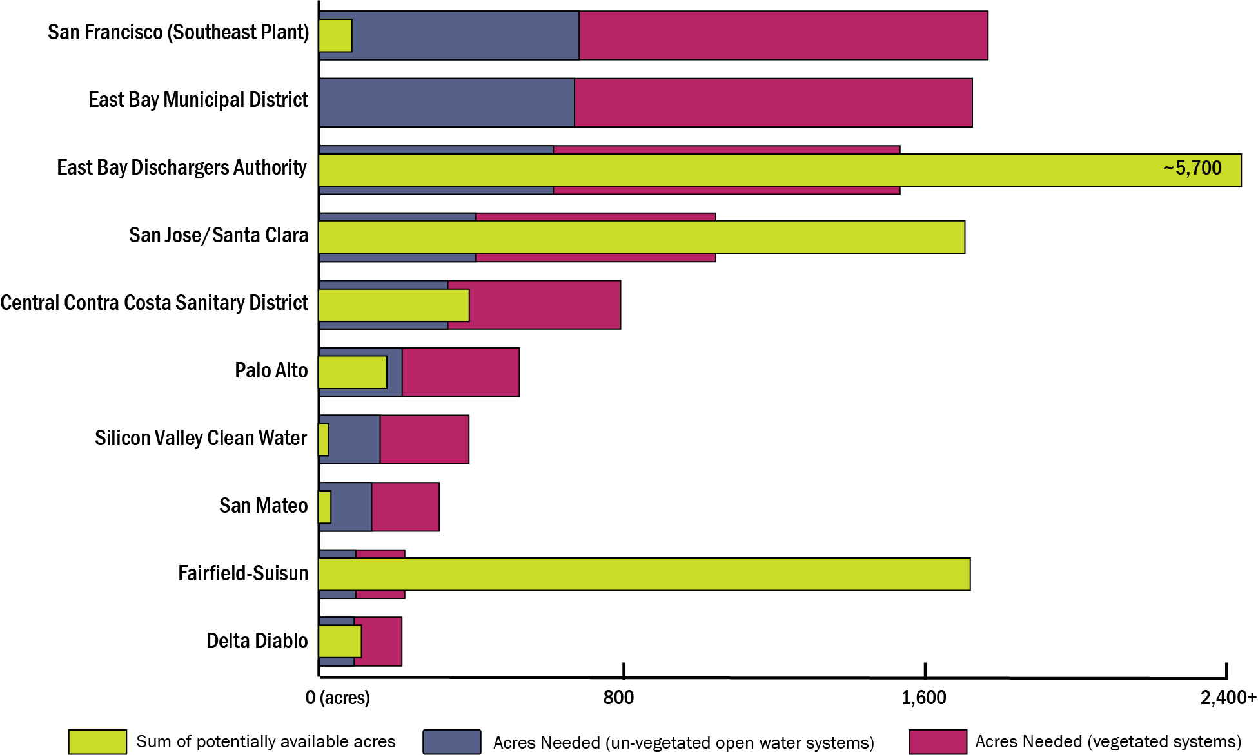
Figure 7. Summary of potentially available acres versus estimated treatment wetland acreage to meet Level 3, from the 10 POTWs with the greatest concentration reduction needs
These results reflect the nitrate removal curves shown in Figure 3. Under an average dry-weather water temperature of 21˚C, ~12 acres is needed to achieve 75% nitrate removal from 1 MDG of wastewater effluent in a Discovery Bay-type system. This compares to ~23 acres needed for a typical FWS treatment wetland. As discussed briefly in Section 3, the FWS estimate could be optimized through design considerations that either increases temperature by reducing depth or enhances exposure of effluent to denitrifying bacteria by increasing sediment surface area and/or hydraulic efficiency. Efforts to reduce wetland area through increased water depth alone will not achieve desired rates of denitrification and photolysis of other wastewater-borne contaminants.
Table 7 distills these results into how much land is potentially available to convert towards FWS treatment wetlands versus what would be needed to achieve various concentration reduction scenarios (Table 7). Facilities with a ratio greater than 1.0 could, based on potentially access to land, achieve the necessary TN concentration reduction requirement via treatment wetlands. This is under the optimistic assumption that all potentially available land could be made available for construction of treatment wetlands.

Figure 8. Natural Treatment Potential at the ‘Big Five’ Bay Area POTWs
Natural treatment opportunities for Bay Area POTWs vary significantly, based largely on degree of surrounding urbanization. Available land within a two mile radius, versus that estimated to be needed to achieve Level 2 (15 mg L⁻¹), Level 3 (6 mg L⁻¹) and Advanced (3 mg L⁻¹) TN removal levels are depicted.
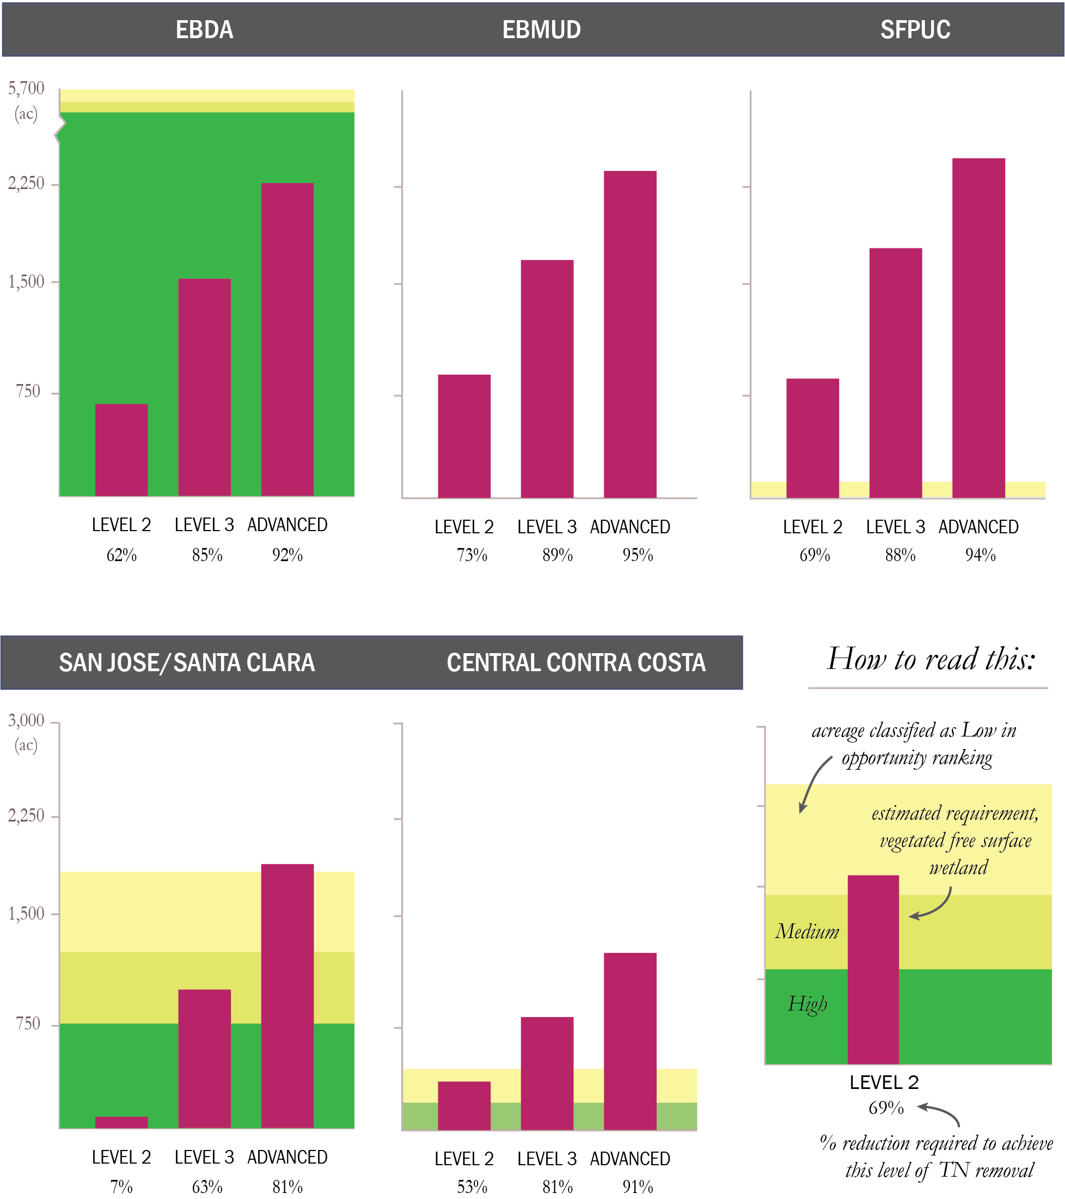

Table 7. Ratio of potentially available land to what is needed, assuming typical performance of FWS treatment wetlands
Discharger | Ratio of Area Available to Needed for Level 2 | Ratio of Area Available to Needed for Level 3 | Ratio of Area Available to Needed for Advanced
Mt. View | 73.5 | 29.4 | 18.4
Sunnyvale | 36.7 | 3.2 | 1.7
San Jose/Santa Clara | 29.0 | 1.8 | 1.0
Fairfield-Suisun | 20.3 | 7.5 | 4.7
East Bay Dischargers Authority | 8.2 | 3.8 | 2.5
San Francisco International Airport | 7.2 | 3.1 | 2.2
Millbrae | 4.5 | 2.5 | 1.7
Benicia | 2.7 | 1.2 | 0.8
Burlingame | 1.8 | 0.8 | 0.5
Central Marin Sanitation Agency | 1.8 | 0.9 | 0.6
West County and City of Richmond | 1.7 | 0.7 | 0.5
Central Contra Costa Sanitary District | 1.2 | 0.5 | 0.3
South San Francisco and San Bruno | 1.2 | 0.5 | 0.3
Delta Diablo | 0.9 | 0.5 | 0.3
Palo Alto | 0.8 | 0.3 | 0.2
Vallejo | 0.4 | 0.2 | 0.1
Pinole | 0.2 | 0.1 | 0.1
San Mateo | 0.2 | 0.1 | 0.1
Silicon Valley Clean Water | 0.2 | 0.1 | 0.1
San Francisco (Southeast Plant) | 0.2 | 0.1 | 0.1
Sausalito-Marin City | 0.0 | 0.0 | 0.0
Marin County (Tiburon) | 0.0 | 0.0 | 0.0
Sewerage Agency of Southern Marin | 0.0 | 0.0 | 0.0
East Bay Municipal Utility District | 0.0 | 0.0 | 0.0
Treasure Island | N/A | 0.0 | 0.0
Napa | N/A | 137.4 | 137.4
Novato | N/A | 75.8 | 37.9
American Canyon | N/A | 39.7 | 15.9
Rodeo Sanitary District | N/A | 1.9 | 1.3
Port Costa Wastewater Treatment Plant | N/A | N/A | N/A
Las Gallinas Valley | N/A | N/A | N/A
Marin County (Paradise Cove) | N/A | N/A | N/A
Petaluma | N/A | N/A | N/A
Sonoma Valley | N/A | N/A | N/A

At the upper end of the spectrum, Mt. View is surrounded by approximately 74 times as much acreage than is needed to meet the Level 2 objective, based on average treatment performance of vegetated FWS treatment systems. A significantly higher ratio would be found assuming performance levels comparable to that observed at the Discovery Bay demonstration project. At the opposite end of the spectrum, EBMUD is virtually landlocked with little to no opportunity for load reduction via treatment wetlands. Some North Bay facilities have potentially significant land opportunities yet discharge insignificant TN loads during the dry season, due to discharge prohibitions. As a result, load reductions are not applicable under some scenarios.
Additional details for the 15 Bay Area POTWs with the greatest TN loading rates, with respect to potential attainment to the Level 2 and 3 scenarios are illustrated in Figures 9 and 10, respectively. These figures summarize average daily dry weather TN load, percent reduction in TN concentration required, estimated acreage in treatment wetland needed to meet this reduction using either shallow basins or typical FWS wetlands, maximum acreage potentially available, and the ratio of potentially available lands to those needed for natural treatment via FWS wetlands alone. It is expected that facilities considering treatment wetlands will design systems of deeper vegetated ponds and shallow unvegetated basins with active biofilms to maximize denitrification while achieving habitat and climate adaptation benefits.

Estimated regional load reduction potential via treatment wetlands
If Level 2 TN concentration reductions (15 mg L⁻¹) were required region-wide, dry weather TN load reductions of ~58% would be required, on a regional scale, based on the average concentrations from 2012 to 2016. This value increases to 92% under the Advanced reduction scenario (Table 8). However, sufficient land area for conversion to treatment wetlands is unavailable to meet these reduction via treatment wetlands alone.
Table 8. Median percent reduction requirements for Bay Area POTWs to meet various levels of treatment
 | Level 2 (15 mg L⁻¹) | Level 3 (6 mg L⁻¹) | Advanced (3 mg L⁻¹)
Region–wide TN reductions to meet scenario (dry weather) | 58% | 83% | 92%
Region-wide area of vegetated FWS treatment wetlands available to meet scenario (ac) | 2,100 ac | 4,500 ac | 6,400 ac
Region-wide TN reduction potential, assuming implementation of FWS wetland acreage provided above | 29% | 41% | 45%
Estimated TN reduction if the same acreage was used entirely for Discovery Bay-like systems | 47% | 58% | 59%
The logarithmic nature of treatment performance versus treatment area reveals a point for each facility where addition of wetland acreage is met with diminishing nitrate removal performance (Figure 3). If analyzed on a regional basis, we see that the addition of significant acreage to meet increasingly stringent TN concentration objectives achieves little, in terms of regionally-significant TN load reductions.
Despite a theoretical three-fold increase in wetland acreage, as individual facilities introduce additional wetland treatment acreage to meet Level 2 versus advanced (3 mg L⁻¹) TN-reduction scenarios, region-wide loading is reduced an additional 16% (from 29% to 45% reduction in TN load). Because some facilities have excess acreage potentially available and others have none, a significant increase in acreage at a select subset of facilities achieves marginal reductions in regional nutrient loading rates. The physical constraints of some of the largest dischargers (i.e. EBMUD and SFPUC) drives this finding.
Information presented here suggests treatment wetlands could potentially play a significant role in achieving moderate regional reductions in TN load (~40-50%), which approaches those reductions needed, on a regional basis, to meet the Level 2 standard (58%). Higher reduction requirements would necessitate optimization and upgrades of facilities and or other multi-benefit solutions, such as wastewater recycling and nutrient recovery.
Figure 9. Summary of Wetland Area Needed Versus Available: Level 2 Objective
The following 15 POTWs represent the largest dry-weather dischargers of TN to San Francisco Bay. In addition to total TN dry-weather average daily load, this figure shows the percent reduction needed to meet a 15 mg L⁻¹ TN effluent standard, estimated acreage to achieve this standard using shallow basins versus typical FWS wetlands, maximum estimated acreage within a 2-mile radius potentially available for treatment wetlands and the ratio of potentially available area to total vegetated treatment wetland area needed.
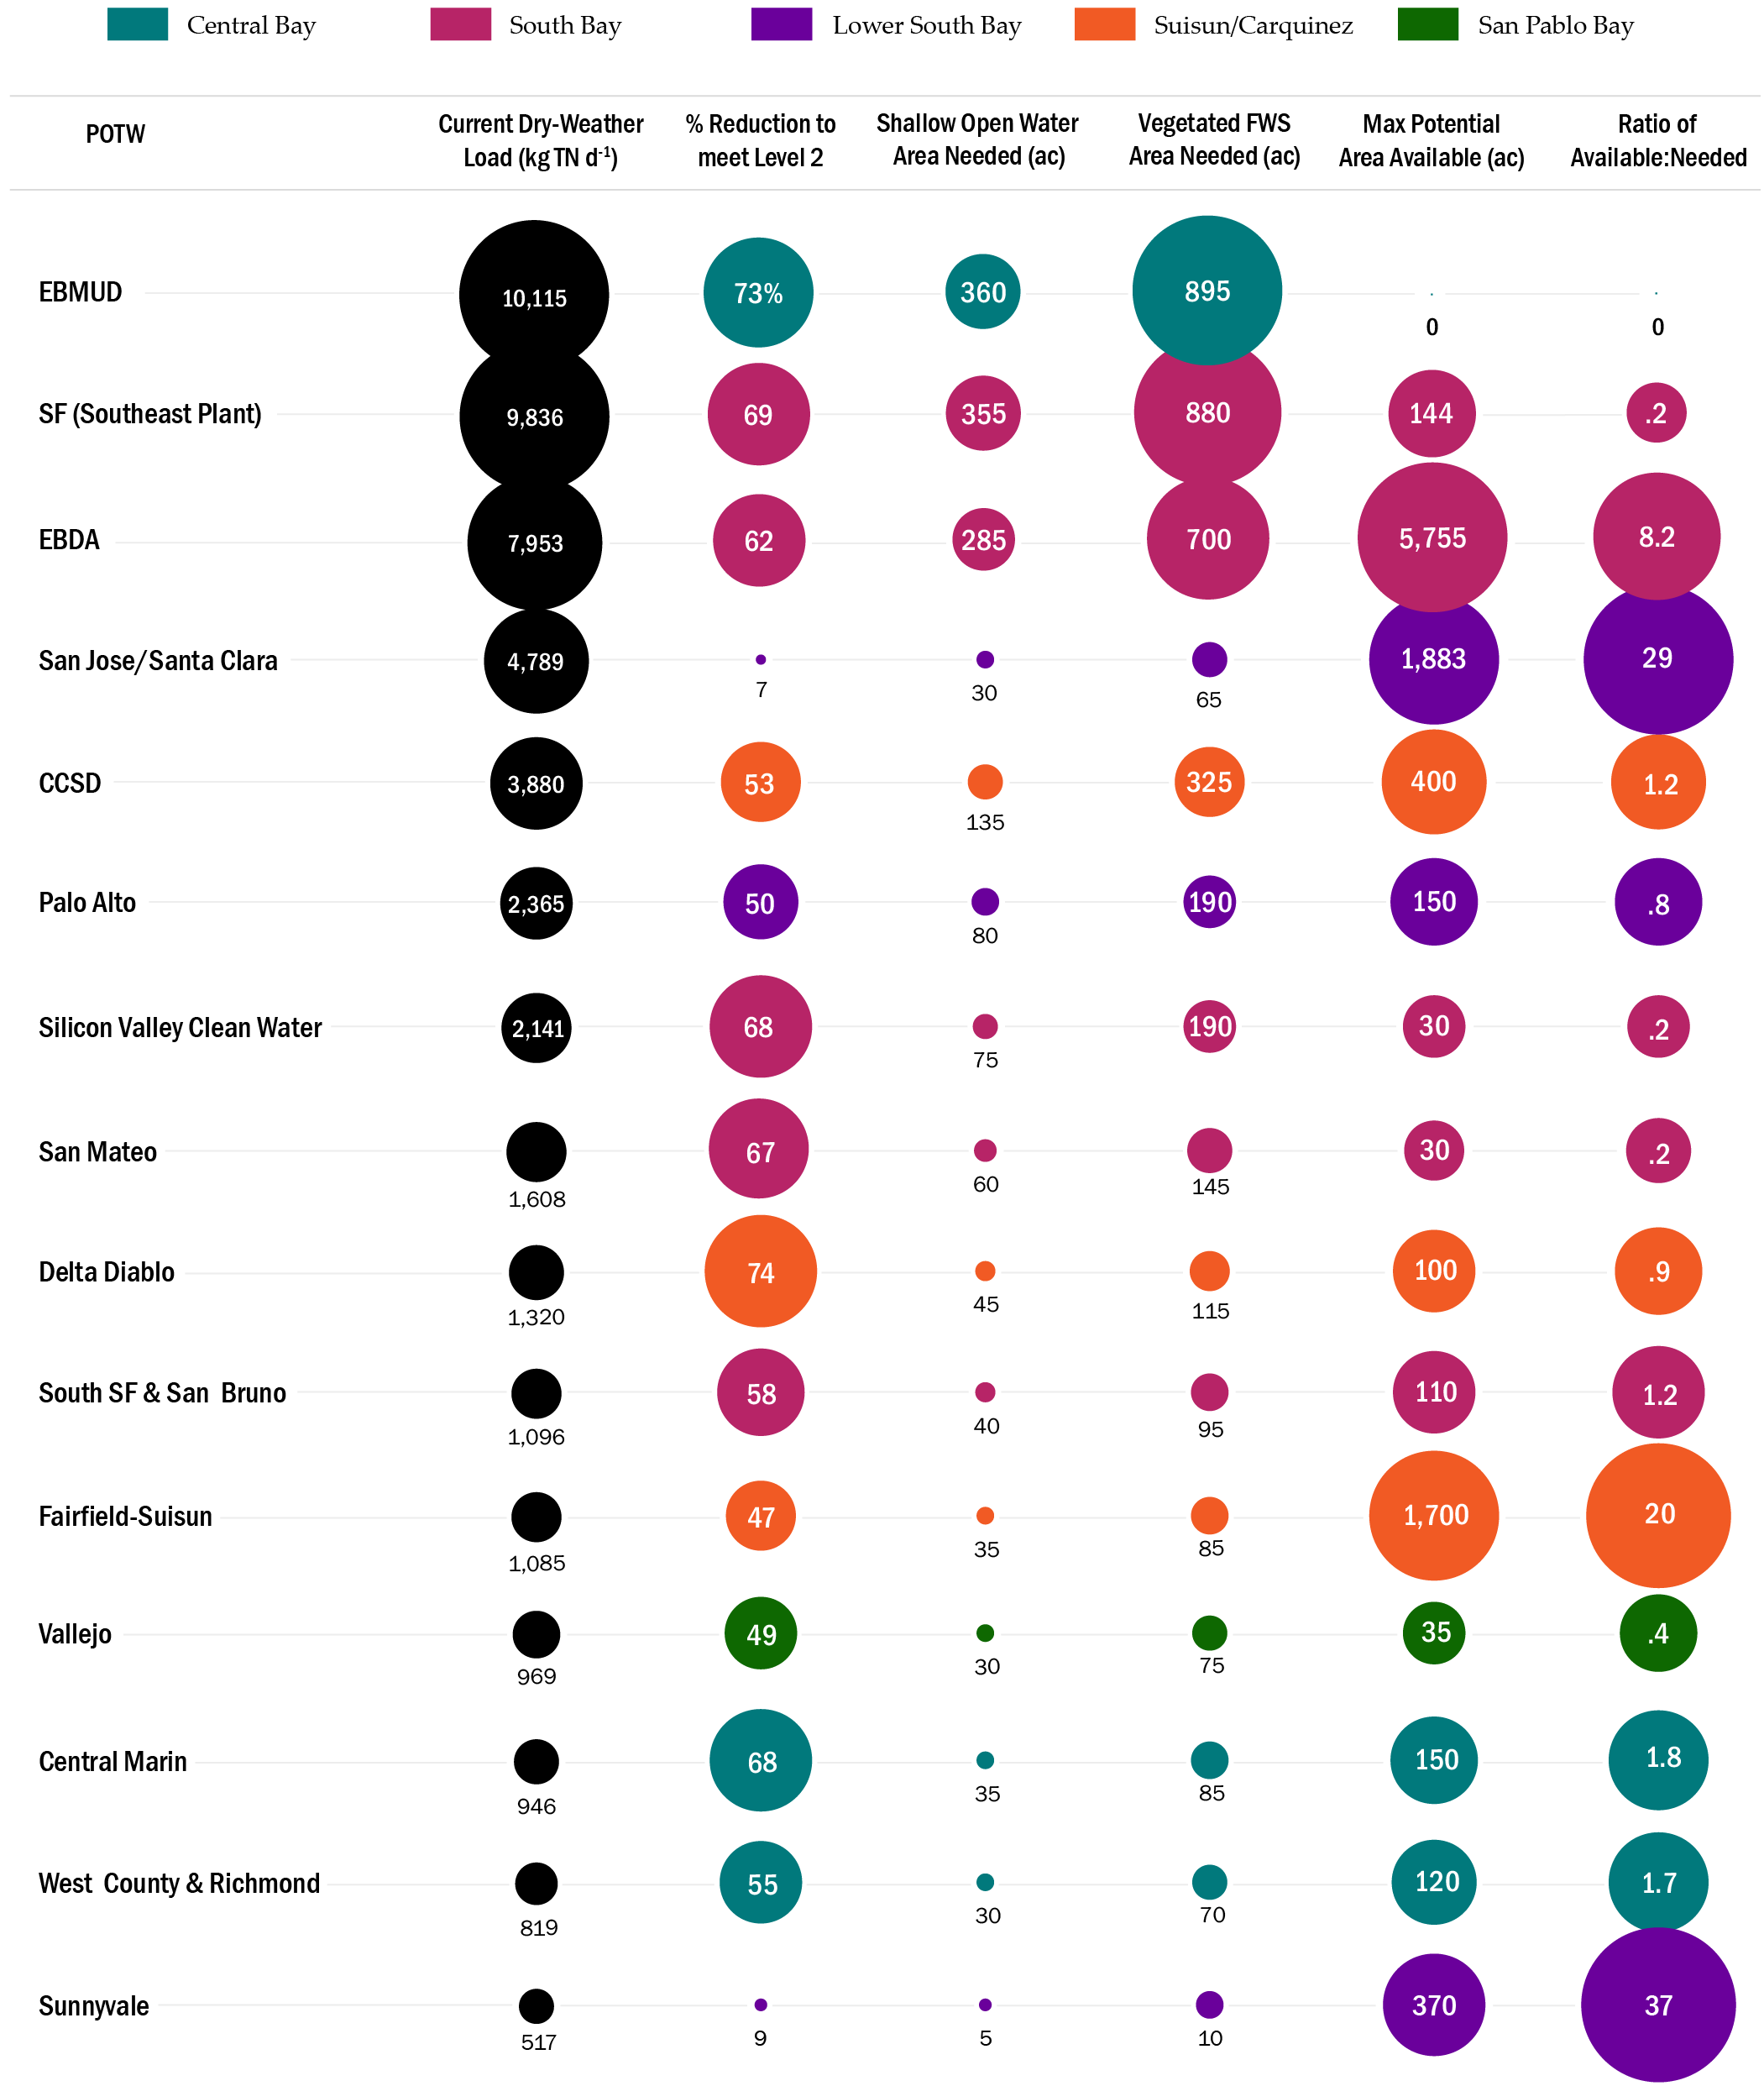
Figure 10. Summary of Wetland Area Needed Versus Available: Level 3 Objective
The following 15 POTWs represent the largest dry-weather dischargers of TN to San Francisco Bay. In addition to total TN dry-weather average daily load, this figure shows the percent reduction needed to meet a 6 mg L⁻¹ TN effluent standard, estimated acreage to achieve this standard using shallow basins versus typical FWS wetlands, maximum estimated acreage within a 2-mile radius potentially available for treatment wetlands and the ratio of potentially available area to total vegetated treatment wetland area needed.
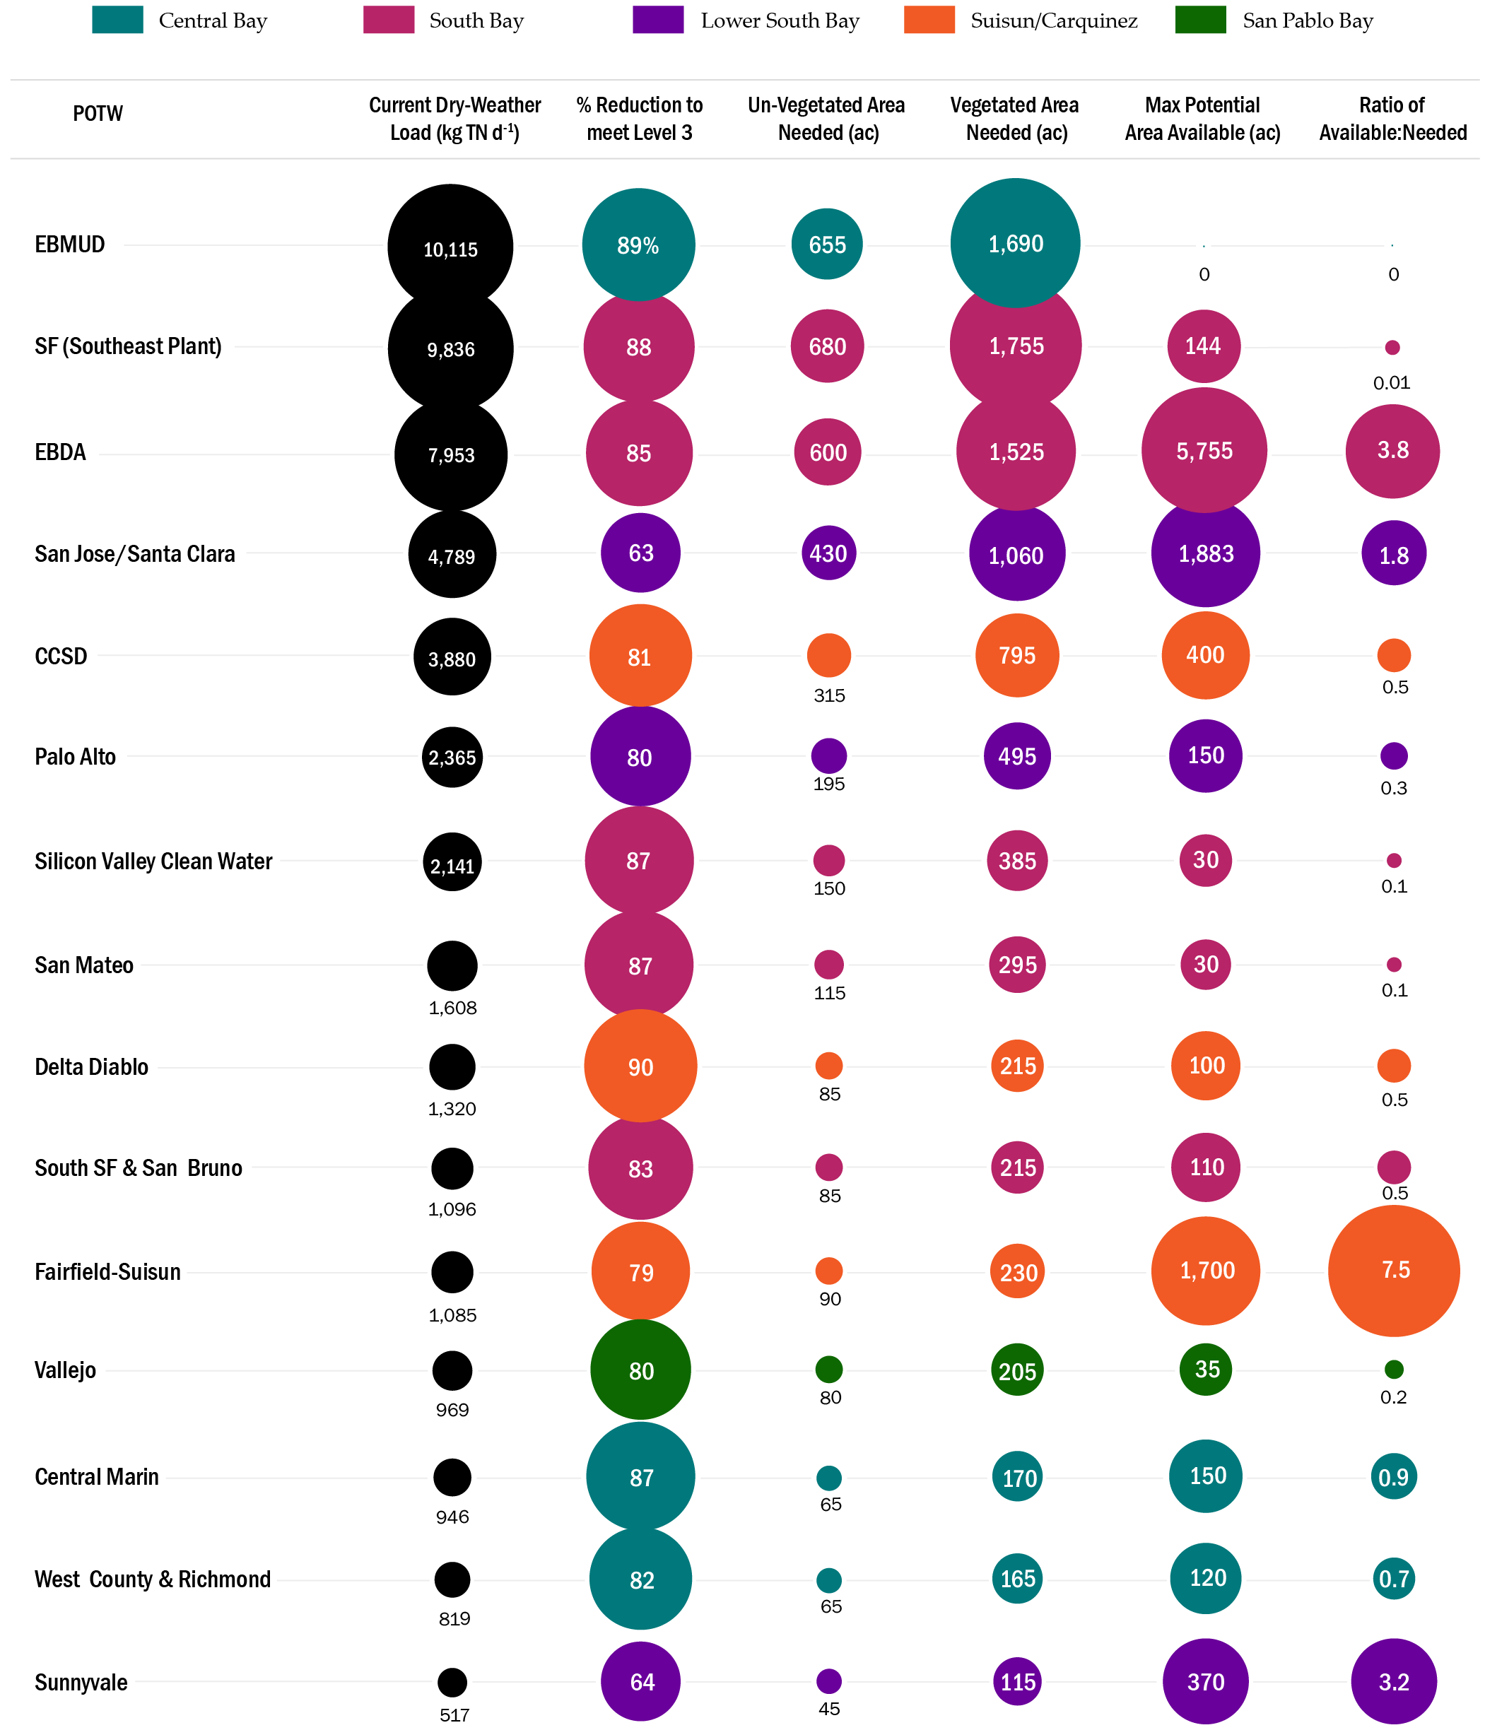

Estimated Costs
Green infrastructure costs vary widely by installation type, location and a number of other factors. This analysis is restricted to consideration of FWS treatment wetlands, for which literature values based on national and international surveys are available.3 The most thorough review is based on analysis of 84 projects yields the following:
Cost = 194 x A^{0.690}
Where: Cost = 2006 dollars ($1,000) & A = area (acres)
These values consider capital costs for construction of the wetlands and exclude land and other potential pre-treatment requirements (e.g. nitrification). Costs are broken down for each concentration reduction scenario, though not every POTW is surrounded by sufficient acreage to meet individual TN concentration reduction scenarios. Acreage and associated costs reflect the cumulative efforts of all facilities to individually maximize attainment of the TN concentration objective via treatment wetlands at their individual facilities, which will not satisfy regional-scale TN concentration scenarios. Additional analysis is required to assess the role of regional cooperation. For instance, whether facilities with surplus acreage could accept treated effluent from a nearby source or trade nutrient credits to achieve a subembayment-scale load cap, for instance.
Table 9. Estimated costs associated with treatment wetland creation for various treatment standards, assuming average performance values for vegetated FWS treatment wetlands
Treatment Objective |  | Level 2 (15 mg L⁻¹) | Level 3 (mg L⁻¹) | Advanced (3 mg L⁻¹)
Total estimated regional capital cost (million $) ª | $70 |  | $120 | $150
Average capital cost, per facility (million $) | $3.4 |  | $4.8 | $5.8
Average capital cost, per acre ($) ^{b} | $52,000 |  | $50,000 | $47,000
Average present value (PV) per facility (million $) ^{c} | $7.9 |  | $9.2 | $10.3
Average PV per acre ^{b,c} | $210,000 |  | $230,000 | $190,000
Average PV cost, per pound nitrate removed ^{c,d} | $1.27 |  | $2.75 | $2.54
- Scaled from 2006 dollars to 2017 ENR CCI for San Francisco 2017 (12,300)
- Sum of available wetlands to meet this standard, region-wide, divided by capital cost or PV.
- PV of capital costs only (excluding land and pre-treatment). Assumes 2% discount rate and 30-year horizon and fixed operations and maintenance costs of $200,000 per facility, regardless of acreage.
- Sum of load reductions estimated over a 30-year span divided by PV.
Costs reflected here are based on national estimates and although they have been scaled for local inflation, the values appear below actual capital costs for the Bay Area, based on recent estimates for comparable facilities. For instance, a recent planning-estimate for a 6-acre treatment wetland at the Hayward Water Pollution Control Plant indicated capital costs of approximately $350k/acre, including earthwork, planting, piping/pumps and control structures, which is ~7 times the amount reflected in Table 9. This did not include land acquisition costs, which were not necessary in this instance, or nitrification facilities.
Engineers involved in the Ellis Creek Water Recycling Facility (Petaluma), however, estimate capital costs for construction of treatment wetlands in California in the range of $50-100k, which is consistent with the literature-based cost estimates provided in Table 9. ¹⁵ In the Hayward case, earthwork was a significant factor in the estimate. Costs increase dramatically when berms and baffles are installed to enhance hydraulic efficiency of the system, in comparison to less efficient ponds, where minimal earthwork is necessary. Yet pond-like systems will likely achieve lower nutrient removal efficiency than a serpentine wetland, given the potential for hydraulic short circuiting, where nutrient-laden waters preferentially flow through the system rapidly with minimal treatment.
The City of Palo Alto also recently commissioned a comparison of cost estimates for several nutrient reduction options, including a compilation of costs for constructed wetlands recently implemented in the Bay Area and elsewhere in California. Costs from these case studies ranged from $300,000 and $1.5 million per acre.¹⁶ This included wetland restoration efforts within heavily urbanized areas, including San Francisco, which is likely not reflective of costs for typical wastewater treatment wetlands. At the high end of the cost spectrum was the Oro Loma ecotone project and other demonstration or pilot projects. Economies of scale associated with full-scale projects in California are difficult to identify from available data, where wetland projects were either installed decades ago or were part of a larger project – posing difficulty in estimating capital cost on an areal basis.
Nitrification is a significant cost for facilities without existing capacity or optimization options, yet is required to convert ammonia-nitrogen from secondary effluent to a level acceptable for wetland application. In general, only POTWs that discharge to North Bay rivers or the Lower South Bay nitrify secondary effluent and preliminary optimization and upgrade estimates indicate widely varying nitrification capacity among the region’s POTWs via optimization of existing features. Based on estimates generated for the Oro Loma ecotone project, the minimum capital cost for a stand-alone nitrification facility is ~$1 million per MGD of flow-through capacity. Information gained through the optimization and upgrade analysis could potentially inform nitrification options at individual facilities.
Estimates provided in Table 9 indicate treatment wetlands offer a cost effective option for nitrate removal, compared with other nutrient upgrade options currently being evaluated. Preliminary estimates from the regional optimization and upgrade study currently underway indicates upgrade costs could be one to two orders of magnitude above those presented above (~$5 billion for regional attainment of the Level 2 standard and ~$7 billion for Level 3). This suggests that even if costs presented here under underestimate the actual cost by several factors, treatment wetlands are worthy of additional analysis when selecting management options for nutrient load reductions.

Opportunities and Constraints of Treatment wetlands & integrated planning
As presented throughout this report, the fundamental constraint to deploying natural treatment of wastewater effluent in an urban setting such as the Bay Area lies in securing sufficient land area to construct wetland treatment wetlands in quantities necessary to meet substantial load reductions. This analysis suggests, however, that in those instances where land is available, TN reductions could be achieved with natural systems at significantly lower cost, compared to traditional grey infrastructure approaches. Other benefits include habitat enhancement, carbon sequestration, sea level rise adaptation, recreational and educational values, as well as regulatory and public support associated with pursuing green alternatives.
This section introduces regulatory, institutional and site-specific constraints, as well as opportunities for deploying regional-scale treatment wetlands through existing planning initiatives or a nutrient trading structure. Methods for weighing various nutrient reduction options have been applied in other regions and are in development at U.C. Berkeley and ReNUWIt (i.e. Multi-Criteria Decision Analysis). Such approaches could assist regional decision making, yet for facilities with capacity for green infrastructure-based strategies, early consideration of the following considerations is recommended.

Constraints

Regulatory Requirements
Projects involving the creation or enhancement of wetlands adjacent to or upland of SF Bay are subject to several regulatory requirements, generally pertaining to protection of water quality and sensitive species. Depending on proximity to sensitive habitats and magnitude of potential impacts, regulatory compliance requirements can range from simple (e.g. <6 months and <$30,000 in fees) to complex (e.g. 2+years and several million dollars in consultant fees and mitigation costs). Factors influencing the degree of regulatory constraints are site specific and will require consultation with regulatory compliance specialists.
Applicable regulations pertaining to the construction or enhancement of treatment wetlands within historical or existing baylands are listed below. These include regulations governing wetlands, habitats and protected species and water quality. A summary of these regulations are provided in Appendix B. Additional regulations that may pertain (i.e. California Environmental Quality Act) are not considered here though may be applicable to a large scale treatment wetland project.
- Clean Water Act (CWA) Section 404 (US Army Corps of Engineers)
- CWA Section 401 & Porter-Cologne Water Quality Control Act (SF Bay RWQCB)
- McAteer-Petris Act administrative permit (Bay Conservation and Development Commission)
- Section 1600 of the California Fish and Game Code (CA Department of Fish and Wildlife)
- Federal Endangered Species Act (U.S. Fish and Wildlife Service and/or National Marine Fisheries Service)
- California Endangered Species Act (CA Department of Fish and Wildlife)
- Magnuson-Stevens Fishery Conservation and Management Act (National Marine Fisheries Service)
Treatment Wetlands and Waters of the U.S.
Consistent with EPA guidance, in most instances it is neither appropriate nor desired to construct treatment wetlands within Waters of the U.S., unless the source water associated with that project can be used to restore a degraded or former wetland.¹⁷ Waters of the U.S. are waters or wetlands regulated by the CWA and by definition, waste treatment systems designed to meet the requirements of the CWA are not considered Waters of the U.S. ¹⁸
While constructed treatment wetlands are generally not considered Waters of the U.S., if one is constructed in an existing Water of the U.S., the area will remain a Water of the U.S. unless an individual CWA Section 404 permit is issued that explicitly identifies it as an excluded waste treatment system designed to meet the requirements of the CWA. And if the constructed treatment wetland is abandoned or is no longer used as a treatment system, it may revert to, or become, a Water of the U.S. if it otherwise meets current definitions, subject to evaluation by the U.S. Army Corps of Engineers and/or the EPA. Additionally, if the constructed treatment wetland is not itself a Water of the U.S. but discharges pollutants into one, the discharge requires CWA Section 401 certification.

Institutional and governance-based challenges
In 2007, the North Bay Watershed Association (NBWA) conducted a report titled Promoting Multi-Benefit Water Projects in the North Bay and the Greater Bay Area, with relevance to regional approaches to utilization of treatment wetlands for nutrient management. ¹⁹ The project entailed the compilation of 58 multi-benefit water-related projects and interviews from 20 agency and NGO representatives in the North Bay and greater Bay Area. The report was commissioned by NBWA to advance multi-benefit projects, in part to take advantage of Integrated Regional Water Management Plan (IRWMP) funding and in response to observations that multi-benefit projects are prioritized in theory, yet most water-related projects tend to serve a single purpose and represent the priorities of either water supply and treatment agencies, or NGO and resource agencies.
Although prepared ten years ago, the findings and conclusions remain relevant to current and future nutrient management efforts. The list below identifies the principal obstacles to developing and implementing multi-benefit projects and the percentage of interviewees that identified the obstacle:
- No one thinking about the big picture or taking the lead (71%)
- Lack of funding, staff (57%)
- Poor communication (within and between agencies, and between agencies, non-governmental organizations, and the public) (38%)
- Benefits of integrated projects unclear, difficult to quantify (33%)
- Lack of regulation or enforcement, confusing jurisdiction, daunting permitting process (29%)
- Lack of quantitative knowledge about basic questions (23%)
- Private property issues (23%)
- Challenges with recycled water (23%)
- Lack of political will for water regulation, mandates (19%)
Interestingly, the principal challenges identified are governance-related, rather than technical. While funding is always a constraint to capital-intensive projects, the integration of water supply, water quality, flood risk, recreation and habitat enhancement priorities is a means for attracting public and private funding that may otherwise be unavailable. Challenges particular to Bay Area POTWs include the management of regional efforts among a number of agencies, though the presence of BACWA serves to ease the associated governance and institutional issues. Recommendations for action from this effort are reflected in Section 7.

Site Specific Constraints: Land Use, Infrastructure and Environmental Conflicts
Regulatory and institutional challenges are generally consistent across regions, whereas constraints related to land use, infrastructure and environmental conflicts require a customized approach. Challenges of this type include:
- Prohibitively high land acquisition costs and/or the need for complex use agreements
- Restrictive land use designations that may prohibit wastewater treatment facilities of any type
- Physical and institutional challenges of meeting multiple infrastructure needs (e.g. flood risk, habitat, water/power conveyance)
- Local objections to utilization of baylands for wastewater treatment or discharging treated effluent to nearshore Waters of the U.S.
Land acquisition and use agreements will be of concern throughout high-cost and built-out portions of the Bay Area. In the Central Bay, for instance, little to no land acquisition opportunity exists and in most other portions of the region treatment wetlands may only be feasible where lead or partner agencies have already acquired land. And environmental conflicts are sure to arise wherever real or perceived threats to existing or planned wetlands could occur. Careful outreach to resource agencies and environmental groups, as well as incorporation of ecological risk management strategies throughout the design stage, must be prioritized to address such concerns. The regional approach to advancing green infrastructure, outlined in Section 7, considers these and other issues.

Opportunities

Regional Initiatives for Integrated Shoreline Planning
Several complementary regional and sub-regional initiatives are underway that could affect wetland planning and potentially help facilitate utilization of existing or created wetlands for multiple benefits, including wastewater treatment:
- Bay Conservation Development Commission’s (BCDC) Adapting to Rising Tides (ART)
- Baylands Ecosystem Habitat Goals Update (BEHGU)
- South Bay Salt Ponds Restoration Project (SBSP)
- Coastal Hazards Adaptation Resiliency Group (CHARG)
- San Francisco Bay Restoration Authority
- BCDC’s Bay Fill Working Group
- SFEI’s Flood 2.0 project
Targeted outreach to the appropriate representatives of these groups, some of which overlap, may result in funding opportunities or avoidance of duplicated regulatory engagement or community outreach. Meetings or a group symposium, targeted towards advancing multi-benefit projects, could engage initiatives with overlapping objectives, potentially resulting in shared resources to achieve mutual outcomes.

Treatment wetlands within a trading structure
Since the greatest opportunity for wetland-related TN load reductions are found at a select number of facilities, treatment wetlands could serve a vital role in a nutrient credit trading structure, in the event such a program is considered viable. Economies of scale could be achieved at facilities with the greatest potential for wetland-driven nitrogen load reductions and the costs for implementing such projects could be shared among facilities, via point-source to point-source trades within a sub-embayment. Hydrodynamic models currently in development by SFEI could be used to prescribe trading ratios among facilities. Management of a trading structure would require new governance structures, likely coordinated through BACWA and the SF Bay RWQCB.
It is unclear whether treatment wetlands have been utilized within nutrient credit trading systems elsewhere, although their use has been contemplated and identified as a sustainable element, providing economic, social and environmental benefits beyond those associated with nutrient reduction.²⁰ The Freshwater Trust recently completed a conceptual approach to nutrient credit trading for the Bay Area, serving as a roadmap for future action.²¹ As regulatory action progresses, these recommendations may receive greater attention.
A trading system would benefit from a total maximum daily load (TMDL) or load cap, on a subembayment scale, to establish transparency and consistency when determining necessary reductions and associated credits. Once the treatment systems are constructed and control structures are in place the managing entity would record influent and effluent loads on a fixed schedule. The mathematical result would represent the earned nutrient credits, in terms of the achieved load reduction. The SF Bay RWQCB could verify the results through review of monitoring reports and occasional site verification.
Operators may be an individual or business entity, following the model of a wetland bank, municipal agency or flood district, for instance. Credit buyers would include POTWs, stormwater agencies or industry, as applicable. Such a system requires a transparent trading system and governance structure, though the framework for such a system has been developed and considered viable.²¹

Recommended approach for integrated regional planning
In the event nutrient-related regulations are imposed, requiring caps or reductions in nutrient loading to San Francisco Bay or other California waterways, a number of approaches are available.²² In other regions where nutrient criteria have been imposed the management response has, on a nearly universal basis, relied on costly yet trusted on-site concrete and steel suspended growth processes.¹⁴ Through outreach conducted in support of the SF Bay Nutrient Management Strategy (NMS) and feedback received via ReNUWIt-led interviews, stakeholders generally recognize additional nutrient management efforts will be required at some point, yet a no-regrets pathway is generally desired that incorporates multiple high-priority objectives into any suite of management alternatives. Under this approach, a hybrid of the general management options identified below could meet this criteria, pending close examination of final management actions.
Table 10. Likely nutrient management strategies for Bay Area POTWs
Management Option | Comments
Optimization and upgrades | For some facilities, optimization or upgrade of existing treatment trains will be the only option available to achieve significant nutrient load reductions or where pre-treatment (e.g. nitrification & advanced filtration) is necessary for wetland application or recycled water distribution. This encompasses dozens of potential approaches and is the subject of on-going analysis.
Non-potable recycled water | Application of non-potable water to agriculture and landscaping represents a potentially cost-effective means to reduce local water demand and nutrient loading to receiving waters. Constraints include the availability of distribution networks and suitable application sites.
Potable recycled water | Forthcoming regulations will likely permit direct potable reuse (DPR) of treated wastewater - thus enhancing regional water resource reliability. This reduces the need for new distribution networks yet challenges remain regarding management of concentrated effluent.
Treatment wetlands | The subject of this report, FWS and other green infrastructure alternatives (e.g. treatment levees) offer strong promise for multi-function nutrient reductions. Primary constraints include land availability in an urban landscape and regulatory/public perception constraints.
Although this report focuses on FWS treatment wetlands, a regional strategy for prioritizing multi-benefit nutrient management should incorporate, at a minimum, those options above. Processes to address optimization and upgrade strategies and underway and statewide initiatives involving recycled water regulation are on-going. A process to particularly assess a multi-benefit nutrient management strategy involving treatment wetlands could follow this general process:
- Identify conservation objectives for treatment wetlands – meeting of agencies and regulators involved in management of existing treatment wetlands to prioritize management objectives for developing water quality and habitat objectives for treatment wetland complexes. The SF Bay RWQCB is currently considering updates to Resolution No. 94-086, presenting opportunity for such considerations.
- Conduct stakeholder workshops for visioning of how integrated bayland restoration projects could sustainably meet multiple objectives (habitat, recreation, water quality). What are the priorities for regulators, resource agencies, environmental groups, wastewater treatment operators and drinking water suppliers?
- Data collection (i.e. land use, land ownership, habitat & soil types, recycled water capacity and forecasted use) to facilitate site-specific opportunities and constraints analysis for treatment wetlands and recycled water.
- Economic analyses:
  - Quantification of single- versus multi-benefit projects
  - Benefit of direct potable use as a management strategy
  - Site-specific wetland treatment estimates
- Assess and develop, as appropriate, a nutrient credit trading structure to promote sub-embayment scale load reduction
- Undertake informal regulatory outreach (SF Bay RWQCB/SWRCB, USEPA, NOAA, USFWS, CDFW, BCDC, ACOE) to identify opportunities and management of hurdles for treatment wetlands and concentrate management, including but not limited to:
  - Identify measurable, result oriented, and practical conservation objectives for treatment wetland complexes (i.e. habitat, species, water quality, recreation, education)
  - Assess critical species issues and locations of priority management actions
  - Evaluate wetland regulations and Bay Fill policies – compatibility of treatment wetlands & CWA/McAteer Petris
  - Incorporate flood risk concerns and management alternatives (i.e. treatment levees and floodplain expansion)
  - Groundwater protection
  - Inform scientific studies for recycled water concentrate management assessment
  - Policies or a general permit template for wetland treatment of treated wastewater effluent - incorporating surface water/groundwater quality, habitat/species protection, and public access/education
- Develop a working group of BACWA representatives and stakeholders to advance the following technical, financial and outreach-based priorities:
Technical | Financial | Outreach
Develop wetland project guidelines | Fundraising | Stakeholder visioning
Integrated modeling for nutrient reduction performance & tradeoffs | Cost-benefit analyses of single- vs. multi-benefit benefit scenarios | Integration of IRWM / SF Bay Restoration Authority / water recycling working groups
Permitting issues & streamlining options | Cost sharing/credit trading | Informal regulatory consultation
Options for direct potable reuse (DPR) & concentrate management | Site-specific cost estimates for wetlands & DPR | Community group/NGO partnerships
Form a Technical Work Group | Form a Financial Work Group | NMS Program Coordination activity
These actions could be phased as the evaluation of management actions progresses. Though given the eventuality of future nutrient management needs, coupled with lengthy time horizons for coordination, fundraising and permitting, some of these actions should be incorporated into existing NMS activities. Identification of stakeholder priorities and partners for early actions will serve as demonstration projects and reduce future implementation timelines. Additionally, if monitoring and assessment indicated the need for more rapid implementation of nutrient load reduction approaches, the region would be well equipped to incorporate multi-function, multi-benefit approaches rather than costly single-function treatment upgrade approaches.
As regulatory approaches for nutrient management progress to the point where criteria are established, final selection criteria, on a facility or sub-embayment scale could follow screening and selection processes and criteria found elsewhere.¹⁴ In the absence of regulatory criteria or guidance, site-specific planning is difficult, though the planning-level actions outlined above would prepare the region for deployment of a sustainable approach to nutrient management at reasonable time scales.

References
- San Francisco Bay Regional Water Quality Control Board. Order No. R2-2014-0014, NPDES No. CA0038873 (Waste Discharge Requirements for Nutrients from Municipal Wastewater Discharges to San Francisco Bay)
- J.T. Jasper et al, Nitrate Removal in Shallow, Open-Water Treatment Wetlands. Environmental Science & Technology. 48:19, 11512-11520 (2014).
- R.H. Kadlek, Constructed Marshes for Nitrate Removal. Critical Reviews in Environmental Science and Technology. 42:9, 934-1005 (2011).
- Bay Area Clean Water Agencies (BACWA), Nutrient Reduction Study, Group Annual Report, Nutrient Watershed Permit Annual Report, 2016, Prepared by HDR Inc on behalf of BACWA.
- R.H. Kadlec and S. Wallace, Treatment Wetlands (2nd ed. CRC Press. Boca Raton, FL, ed. 2, 2009)
- R.W. Crites et al., Natural Wastewater Treatment Systems (CRC Press. Boca Raton, FL, ed. 2, 2014)
- B. Arheimer and H.B. Wittgren, Modeling the effects of wetlands on regional nitrogen transport. Ambio. 23:6, 378–386 (1994).
- R.H. Kadlec and S. Wallace, Treatment Wetlands (2nd ed. CRC Press. Boca Raton, FL, ed. 2, 2009), p. 283.
- Monthly self-monitoring report (SMR) data from CIWQS for East Bay Regional Park District, Union SD & EBDA (NPDES R2-2011-0058). Accessed on February 12, 2017.
- U.S. Environmental Protection Agency, Constructed Wetlands for Wastewater Treatment and Wildlife Habitat, 17 Case Studies (EPA Publication EAP832-R-93-005, 1993; www.epa.gov/wetlands/constructed-wetlands-wastewater-treatment-and-wildlife-habitat-17-case-studies).
- “Staff Report – Wetland Policy Climate Change Update Project NPDES Permit Case Studies: Findings and Recommendations,” San Francisco Bay Region & San Francisco Estuary Partnership, April 2017.
- C. Campbell, “Plant Optimization for Nutrient Removal & Diversion (Phase II): Renzel Marsh & Recycled Water”, Palo Alto Regional Water Quality Control Plant, 2015.
- State Water Resources Control Board. “Resolution No. 94-107 (Approval of the Regional Water Quality Control Board, San Francisco Bay Region, Resolution No. 94-102: Policy on the Use of Constructed Wetlands for Urban Runoff Pollution Control)”, 1994, www.waterboards.ca.gov.
- The Nutrient Roadmap (Water Environment Federation, Alexandria VA, 2015).
- Personal communication with Doug Wing, Corollo Engineers. May 10, 2017.
- J. Yan and M. Cousins (RMC and Woodard & Curran), “Technical Memorandum: Nutrient Load Reduction Alternatives Cost Comparison,” Prepared on behalf of the City of Palo Alto, 2017.
- U.S. Environmental Protection Agency. Guiding Principles for Constructed Treatment Wetlands: Providing for Water Quality and Wildlife Habitat (EPA Publication 843-B-00-003, 2000; www.epa.gov/wetlands/guiding-principles-constructed-treatment-wetlands-providing-water-quality-and-wildlife).
- 40 CFR 122.2 9
- A. Dawson and C. Cornwall (Sonoma Ecology Center), “Promoting Multi‐Benefit Water Projects in the North Bay and the Greater Bay Area,” Prepared on behalf of the North Bay Watershed Association (NBWA), 2007; http://knowledge.sonomacreek.net).
- D.L. Hey, J.A. Kostel, A.P. Hurter and R.H. Kadlek, ”Nutrient Farming and Traditional Removal, an Economic Comparison” (Report 03-WSM-6CO, Water Environment Research Foundation. Alexandria, VA, 2005).
- “Nutrient Trading in the SF Bay Foundations & Concepts”. Presentation from Alex Johnson (Freshwater Trust) to the NMS Steering Committee. March 10, 2017.
- Nutrient Removal (WEF Manual of Practice No. 34), Water Environment Federation, Alexandria, VA, 2010)

Appendix A: Screening Procedure for Identifying Land Potentially Suitable for COnversion to Treatment Wetlands
To determine suitability of individual land areas for potential use as treatment wetland sites, the following assumptions and exclusion criteria were used, via GIS, to identify potential areas for restoration, enhancement or creation of treatment ponds or wetlands:
Assumptions:
- Screening factors only consider physical factors for site selection and screening. Land use, economic and permitting factors are not considered here and would require detailed site-specific analysis.
- Soil permeability of the most restrictive soil layer assumed to be too low (e.g. <0.15 cm/hr) to prove suitable for infiltration-based treatment processes. This is given the proximity to the Bay and restrictive clay soils for most facilities. Site-specific analysis, outside the scope of this effort, may prove some sites suitable for infiltration-based systems.
- Land use and habitat type/quality play a role in the degree of likelihood that a parcel can be developed. Data sources used for this analysis included:
  - Modern Baylands (EcoAtlas) (1998)
  - Bay Area Aquatic Resource Inventory (BAARI) (2016)
  - Inventory of South Bay Salt Pond Restoration Project and other wetland restoration sites
  - Association of Bay Area Governments (ABAG) land use (2005)
- Based on land/habitat classifications and best professional judgement, opportunity for use as a natural treatment system are ranked according to the following ranking system. Habitat classifications are taken from the SHORT_DEFN field of SFEI’s EcoAtlas GIS data and ABAG’s CLASS field:
  - Low Suitability: Suggests utilization for natural treatment systems would pose significant regulatory hurdles and/or require innovative treatment designs.
    - Includes Lagoons, Lakes on fill, Managed marsh and Diked Marsh where signs of degraded habitat conditions are present. Otherwise these types were excluded.
  - Medium Suitability: Indicates historical precedent for use of this land use/habitat type for natural treatment, yet permitting and mitigation could be significant.
    - Typical habitat classifications include: former salt ponds not currently intended for restoration (i.e. Crystallizer, Medium & Low Salinity Salt Ponds), former military lands, urban open space
  - High Suitability: Suggests land could likely be utilized for treatment processes under a relatively predictable permitting process.
    - Typical habitat classifications include: Undeveloped Bayland, Storage or Treatment Basin (e.g. existing oxidation ponds or treatment ponds), Farmed Bayland, Undeveloped Fill, Developed Island or Fill, Undefined Bayland, Ruderal Bayland, Agriculture, Rangeland
Areas excluded from consideration:
- Existing tidal marsh and other intact wetland habitats (based on aerial inspection and SFEI’s BAARI and EcoAtlas data). Some managed marshes were included where degraded conditions were visually evident and potential for enhancement or management for multiple benefits were considered and ranked as ‘1’ under the system identified above;
- Lands and former salt ponds planned for restoration (i.e. South Bay Salt Pond Restoration areas and other restoration sites);
- Existing industrial, high density, residential or urban lands;
- Areas further than 3.2 km (2 mile) from a wastewater source;
- Areas with a site grade greater than 6%; and
- Areas greater than 15 m in elevation distance from a wastewater source.

Appendix B: 2012-2016 Average Seasonal POTW Flows and Total Nitrogen Loads

Self-reported data of average seasonal flow and TN loading from BACWA’s 2016 Group Annual Report, Nutrient Watershed Permit Annual Report
Discharger | 2012-16 dry season flow (MGD) | 2012-16 wet season flow (MGD) | 2012-16 Dry Season TN (kg N d⁻¹) | 2012-16 Wet Season TN (kg N d⁻¹) | 2012-16 Annual Average TN (kg N d⁻¹)
American Canyon | 1.2 | 1.6 | 54 | 65 | 61
Benicia | 1.9 | 2.2 | 219 | 229 | 225
Burlingame | 2.6 | 3.2 | 364 | 482 | 433
Central Contra Costa Sanitary District | 31.8 | 37.5 | 3,880 | 4,238 | 4,089
Central Marin Sanitation Agency | 5.3 | 8.5 | 946 | 961 | 955
Port Costa Wastewater Treatment Plant | 0.0 | 0.0 | - | 1 | -
Delta Diablo | 6.0 | 7.5 | 1,320 | 1,661 | 1,519
East Bay Dischargers Authority | 53.2 | 65.5 | 7,953 | 9,285 | 8,730
East Bay Municipal Utility District | 47.6 | 60.8 | 10,115 | 10,745 | 10,483
Fairfield-Suisun | 10.2 | 14.6 | 1,085 | 1,279 | 1,198
Las Gallinas Valley | 0.0 | 2.4 | 0 | 34 | 20
Marin County (Paradise Cove) | 0.0 | 0.0 | 2 | 2 | 2
Marin County (Tiburon) | 0.5 | 0.7 | 60 | 68 | 64
Millbrae | 1.3 | 1.7 | 272 | 278 | 276
Mt. View | 1.2 | 1.3 | 113 | 133 | 125
Napa | 0.3 | 8.8 | 14 | 362 | 217
Novato | 0.8 | 4.7 | 43 | 238 | 160
Palo Alto | 20.7 | 20.4 | 2,365 | 2,356 | 2,360
Petaluma | 0.0 | 6.0 | 0 | 66 | 38
Pinole | 2.4 | 2.6 | 323 | 312 | 331
Rodeo Sanitary District | 0.5 | 0.7 | 34 | 40 | 38
San Francisco International Airport | 1.0 | 1.1 | 193 | 185 | 188
San Francisco (Southeast Plant) | 54.1 | 58.9 | 9,836 | 9,732 | 9,775
San Jose/Santa Clara | 78.7 | 89.7 | 4,789 | 5,674 | 5,305
San Mateo | 9.4 | 11.0 | 1,608 | 1,495 | 1,542
Sausalito-Marin City | 1.1 | 1.5 | 149 | 140 | 144
Sewerage Agency of Southern Marin | 1.9 | 2.9 | 190 | 265 | 234
Sonoma Valley | 0.0 | 1.6 | 0 | 36 | 21
Silicon Valley Clean Water | 11.9 | 13.8 | 2,141 | 2,355 | 2,266
South San Francisco and San Bruno | 8.1 | 9.1 | 1,096 | 1,170 | 1,139
Sunnyvale | 8.3 | 12.0 | 517 | 1,068 | 838
Treasure Island | 0.3 | 0.4 | 17 | 17 | 17
Vallejo | 8.7 | 10.7 | 969 | 1,042 | 1,012
West County and City of Richmond | 6.5 | 9.8 | 819 | 1,019 | 936

Appendix C: Facility-Specific Results (Reduction Potential & Estimated Cost)
Analysis presented in this report relies on the assumption that total Nitrogen (TN) is first fully converted to nitrate (NO₃ˉ) prior to discharge to treatment wetlands. This is partly due to the fact that free water surface (FWS) treatment wetlands are particularly well suited for NO₃ˉ removal but it also follows the practice of nitrifying wastewater discharges to a freshwater system to avoid ammonia toxicity. Evaluation of site-specific nitrification facilities have not been evaluated here, which could include grey or green infrastructure-based approaches.
Several models and methods are available from the literature to estimate nutrient removal from wetlands and other wetland sizing parameters. This analysis relied solely on the tanks-in-series model, which was transformed to calculate wetland area needs for corresponding nitrate concentration reduction scenarios:
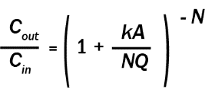
Where:
C_{out} is the outlet NO₃ − concentration,
C_{in} is the inlet NO₃ − concentration,
k is the areal removal rate (m yr⁻¹ ),
A is the wetland area (m² ),
Q is the influent flow rate (m³ yr⁻¹ ), and
N is the number of tanks-in-series used to describe the cell hydraulics.
First order rate constants were taken from a recent demonstration project at the Town of Discovery Bay’s wastewater treatment plant and compared against literature-based average nitrate removal rates from 84 FWS systems., The k value reflects a strong seasonal dependence of NO₃ˉ removal, consistent with the effect of water temperature on denitrification rates, as predicted by the modified Arrhenius equation:
k = k₂₀θ^{(T-20)}
Where θ is the temperature coefficient, k₂₀ is the first-order removal rate at 20 °C (m yr⁻¹), and T is the water temperature (°C).
For the Discovery Bay installation, k₂₀ was 59.4, whereas an average value for vegetated free water surface (FWS) treatment wetlands is 25, reflecting higher treatment performance from the unvegetated shallow basin system at Discovery Bay. In addition to k_{20,} N is a value particular to the system in question. Jasper et al (2014) assumed an N of 6.4 for the optimized shallow basin whereas Kadlek (2011) used a value of 4.4 to represent average FWS wetland systems. The higher N value suggests a serpentine system with longer hydraulic residence time.
Table C-1 indicates the estimated TN removal needed to achieve each of the three (3) TN concentration reduction scenarios; the amount of treatment wetland acreage needed assuming optimized Discovery Bay-type systems versus average FWS wetland systems; and the amount of acreage located within a two mile radius of the facility under each of the ranking classes for suitability of conversion to treatment wetlands (Low, Medium and High).
When assessing the capacity of an individual facility to meet the concentration reduction scenarios, the lesser value of the acreage needed versus that available was used to reflect site-specific constraints. For instance, approximately 55 acres are available, were Burlingame to maximize all potentially usable area within 2 miles of its POTW. About 30 acres are needed to route its treated effluent through FWS treatment wetlands to achieve Level 2 (15 mg L⁻¹) compliance whereas 105 acres are needed to meet Advanced (3 mg L⁻¹) TN levels. When determining the amount needed for Advanced TN reduction, only 55 acres were assumed to be available, which translates into ~75% TN reduction, which is less than the 92% reduction needed to achieve final TN concentrations of 3 mg L⁻¹.
Table C-2 summarizes literature-based cost estimates based on the following gross estimation:
Cost = 194 x A^{0.690}
Where: Cost = 2006 dollars ($1,000) & A = area (acres)
Costs were scaled from March 2006 national ENR CCI (7,856) to forecasted 2017 values for San Francisco (12,300) and estimated based on eq. 23.1 in Treatment Wetlands (Kedlak).² Present Value (PV) was provided for capital costs only (excluding land and pre-treatment/nitrification), assuming a 2% discount rate and 30-year horizon and fixed operations and maintenance costs of $200,000 per facility, regardless of acreage. As discussed in Section 5.4 of the report, these values likely represent the minimum possible capital costs of installation. Planning, permitting, mitigation and price escalation associated with construction in urban centers could increase these values significantly. Site-specific analysis is required to enhance certainty associated with these values.

Table C-1. Acreage needed to achieve concentration reduction scenarios versus potentially available land
Discharger | Acres to achieve Level 2 reduction (15 mg L⁻¹ TN) |  |  | Acres to achieve Level 3 reduction (6 mg L⁻¹ TN) |  |  | Acres to achieve advanced reduction (3 mg L⁻¹ TN) |  |  | Acres Available, According to Opportunity Ranking
 | Estimated % Reduction | Optimized (ac) | Average FWS (ac) | Estimated % Reduction | Optimized (ac) | Average FWS (ac) | Estimated % Reduction | Optimized (ac) | Average FWS (ac) | LOW | Med | High | SUM
American Canyon | 0% | 0 | 0 | 50% | 5 | 10 | 75% | 10 | 25 | 53 | 173 | 171 | 397
Benicia | 51% | 5 | 20 | 80% | 20 | 45 | 90% | 25 | 70 | 22 | 0 | 32 | 53
Burlingame | 59% | 15 | 30 | 84% | 30 | 70 | 92% | 40 | 105 | 23 | 0 | 31 | 55
Central Contra Costa Sanitary District | 53% | 135 | 325 | 81% | 315 | 795 | 91% | 470 | 1,220 | 158 | 0 | 242 | 401
Central Marin Sanitation Agency | 68% | 35 | 85 | 87% | 65 | 170 | 94% | 95 | 245 | 81 | 0 | 71 | 152
Port Costa Wastewater Treatment Plant | 0% | 0 | 0 | 0 | 0 | 0 | 0 | 0 | 0 | 0 | 0 | 10 | 10
Delta Diablo | 74% | 45 | 115 | 90% | 85 | 215 | 95% | 115 | 310 | 66 | 0 | 38 | 104
East Bay Dischargers Authority | 62% | 285 | 700 | 85% | 600 | 1,525 | 92% | 865 | 2,275 | 559 | 692 | 4,504 | 5,755
East Bay Municipal Utility District | 73% | 360 | 895 | 89% | 655 | 1,690 | 95% | 905 | 2,415 | 0 | 0 | 0 | 0
Fairfield-Suisun | 47% | 35 | 85 | 79% | 90 | 230 | 89% | 140 | 365 | 850 | 0 | 874 | 1,725
Las Gallinas Valley | 0% | 0 | 0 | 0 | 0 | 0 | 0 | 0 | 0 | 57 | 0 | 582 | 638
Marin County (Paradise Cove) | 65% | 0 | 0 | 86% | 0 | 0 | 93% | 0 | 0 | 0 | 0 | 0 | 0
Marin County (Tiburon) | 53% | 0 | 5 | 81% | 5 | 10 | 91% | 5 | 20 | 0 | 0 | 0 | 0
Millbrae | 73% | 10 | 25 | 89% | 20 | 45 | 95% | 25 | 65 | 89 | 0 | 23 | 112
Mt. View | 40% | 5 | 10 | 76% | 10 | 25 | 88% | 15 | 40 | 265 | 0 | 470 | 735
Napa | 0% | 0 | 0 | 51% | 0 | 5 | 76% | 0 | 5 | 99 | 10 | 578 | 687
Novato | 0% | 0 | 0 | 58% | 5 | 10 | 79% | 5 | 20 | 52 | 189 | 517 | 758
Palo Alto | 50% | 80 | 190 | 80% | 195 | 495 | 90% | 295 | 765 | 44 | 0 | 109 | 153
Petaluma | 0% | 0 | 0 | 0 | 0 | 0 | 0 | 0 | 0 | 168 | 0 | 544 | 712
Pinole | 58% | 10 | 30 | 83% | 25 | 65 | 92% | 35 | 95 | 0 | 0 | 7 | 7
Rodeo Sanitary District | 16% | 0 | 0 | 67% | 5 | 10 | 83% | 5 | 15 | 3 | 0 | 15 | 19
San Francisco International Airport | 71% | 5 | 15 | 88% | 15 | 35 | 94% | 20 | 50 | 80 | 0 | 29 | 109
San Francisco (Southeast Plant) | 69% | 355 | 880 | 88% | 680 | 1,755 | 94% | 965 | 2,550 | 2 | 0 | 142 | 144
San Jose/Santa Clara | 7% | 30 | 65 | 63% | 430 | 1,060 | 81% | 775 | 1,960 | 606 | 518 | 759 | 1,883
San Mateo | 67% | 60 | 145 | 87% | 115 | 295 | 93% | 165 | 430 | 4 | 0 | 25 | 29
Sausalito-Marin City | 58% | 5 | 15 | 83% | 10 | 30 | 92% | 15 | 45 | 0 | 0 | 1 | 1
Sewerage Agency of Southern Marin | 43% | 5 | 15 | 77% | 15 | 40 | 89% | 25 | 65 | 0 | 0 | 0 | 0
Sonoma Valley | 0% | 0 | 0 | 0 | 0 | 0 | 0 | 0 | 0 | 10 | 0 | 357 | 368
Silicon Valley Clean Water | 68% | 75 | 190 | 87% | 150 | 385 | 94% | 210 | 560 | 3 | 1 | 31 | 34
South San Francisco and San Bruno | 58% | 40 | 95 | 83% | 85 | 215 | 92% | 125 | 330 | 73 | 0 | 37 | 110
Sunnyvale | 9% | 5 | 10 | 64% | 45 | 115 | 82% | 85 | 210 | 218 | 0 | 148 | 367
Treasure Island | 0% | 0 | 0 | 60% | 0 | 5 | 80% | 5 | 5 | 0 | 0 | 0 | 0
Vallejo | 49% | 30 | 75 | 80% | 80 | 205 | 90% | 120 | 315 | 0 | 0 | 34 | 34
West County and City of Richmond | 55% | 30 | 70 | 82% | 65 | 165 | 91% | 95 | 255 | 25 | 0 | 96 | 121

Table C-2. Estimated costs for treatment wetland construction, based on literature values (see notes below)
Discharger | Estimated Capital Cost Toward Meeting Level 2 (vegetated) ($1,000)¹ | Level 2 PV (vegetated) ($1,000)² | Level 2 PV per Acre (vegetated) ($1,000) | Level 2 PV per pound NO³ (vegetated) ($) | Estimated Capital Cost Toward Meeting Level 3 (vegetated) ($1,000) | Level 3 PV (vegetated) ($1,000) | Level 3 PV per Acre (vegetated) ($1,000) | Level 3 PV per pound NO³ (vegetated) ($) | Estimated Capital Cost Toward Meeting Advanced (vegetated) ($1,000) | Advanced PV (vegetated) ($1,000) | Advanced PV per Acre (vegetated) ($1,000) | Advanced PV per pound NO3 (vegetated) ($)
American Canyon | N/A | N/A | N/A | N/A | $800 | $5,300 | $500 | $8.68 | $1,500 | $6,000 | $200 | $6.03
Benicia | $1,300 | $5,800 | $300 | $2.01 | $2,200 | $6,700 | $200 | $1.60 | $2,500 | $7,000 | $100 | $1.58
Burlingame | $1,700 | $6,200 | $200 | $1.23 | $2,600 | $7,100 | $100 | $1.05 | $2,600 | $7,100 | $100 | $1.05
Central Contra Costa Sanitary District | $8,800 | $13,300 | $40 | $0.27 | $10,200 | $14,600 | $40 | $0.26 | $10,200 | $14,600 | $40 | $0.26
Central Marin Sanitation Agency | $3,500 | $8,000 | $100 | $0.51 | $5,200 | $9,700 | $100 | $0.50 | $5,200 | $9,700 | $100 | $0.50
Port Costa Wastewater Treatment Plant | N/A | N/A | N/A | N/A | N/A | N/A | N/A | N/A | N/A | N/A | N/A | N/A
Delta Diablo | $4,000 | $8,500 | $100 | $0.38 | $4,000 | $8,500 | $100 | $0.38 | $4,000 | $8,500 | $100 | $0.38
East Bay Dischargers Authority | $14,900 | $19,400 | $30 | $0.16 | $25,600 | $30,100 | $20 | $0.19 | $33,700 | $38,200 | $20 | $0.22
East Bay Municipal Utility District | N/A | N/A | N/A | N/A | N/A | N/A | N/A | N/A | N/A | N/A | N/A | N/A
Fairfield-Suisun | $3,500 | $8,000 | $100 | $0.65 | $6,900 | $11,400 | $100 | $0.56 | $9,500 | $14,000 | $40 | $0.60
Las Gallinas Valley | N/A | N/A | N/A | N/A | N/A | N/A | N/A | N/A | N/A | N/A | N/A | N/A
Marin County (Paradise Cove) | N/A | N/A | N/A | N/A | N/A | N/A | N/A | N/A | N/A | N/A | N/A | N/A
Marin County (Tiburon) | N/A | N/A | N/A | N/A | N/A | N/A | N/A | N/A | N/A | N/A | N/A | N/A
Millbrae | $1,500 | $6,000 | $200 | $1.24 | $2,200 | $6,700 | $200 | $1.16 | $2,900 | $7,400 | $100 | $1.19
Mt. View | $800 | $5,300 | $500 | $4.15 | $1,500 | $6,000 | $200 | $2.88 | $2,100 | $6,600 | $200 | $2.74
Napa | N/A | N/A | N/A | N/A | $500 | $5,000 | $1,000 | $21.27 | $500 | $5,000 | $1,000 | $21.27
Novato | N/A | N/A | N/A | N/A | $800 | $5,300 | $500 | $8.50 | $1,300 | $5,800 | $300 | $6.85
Palo Alto | $5,200 | $9,700 | $100 | $0.40 | $5,200 | $9,700 | $100 | $0.40 | $5,200 | $9,700 | $100 | $0.40
Petaluma | N/A | N/A | N/A | N/A | N/A | N/A | N/A | N/A | N/A | N/A | N/A | N/A
Pinole | $600 | $5,100 | $800 | $3.28 | $600 | $5,100 | $800 | $3.28 | $600 | $5,100 | $800 | $3.28
Rodeo Sanitary District | N/A | N/A | N/A | N/A | $800 | $5,300 | $500 | $8.59 | $1,100 | $5,500 | $400 | $7.88
San Francisco International Airport | $1,100 | $5,500 | $400 | $1.81 | $1,900 | $6,400 | $200 | $1.54 | $2,400 | $6,900 | $100 | $1.57
San Francisco (Southeast Plant) | $5,000 | $9,500 | $100 | $0.21 | $5,000 | $9,500 | $100 | $0.21 | $5,000 | $9,500 | $100 | $0.21
San Jose/Santa Clara | $2,900 | $7,400 | $100 | $0.99 | $19,900 | $24,400 | $20 | $0.34 | $29,600 | $34,100 | $20 | $0.37
San Mateo | $1,700 | $6,200 | $200 | $0.73 | $1,700 | $6,200 | $200 | $0.73 | $1,700 | $6,200 | $200 | $0.73
Sausalito-Marin City | N/A | N/A | N/A | N/A | N/A | N/A | N/A | N/A | N/A | N/A | N/A | N/A
Sewerage Agency of Southern Marin | N/A | N/A | N/A | N/A | N/A | N/A | N/A | N/A | N/A | N/A | N/A | N/A
Sonoma Valley | N/A | N/A | N/A | N/A | N/A | N/A | N/A | N/A | N/A | N/A | N/A | N/A
Silicon Valley Clean Water | $1,900 | $6,300 | $200 | $0.60 | $1,900 | $6,300 | $200 | $0.60 | $1,900 | $6,300 | $200 | $0.60
South San Francisco and San Bruno | $3,800 | $8,200 | $100 | $0.54 | $4,200 | $8,600 | $100 | $0.52 | $4,200 | $8,600 | $100 | $0.52
Sunnyvale | $800 | $5,300 | $500 | $4.60 | $4,300 | $8,800 | $100 | $1.11 | $6,500 | $11,000 | $100 | $1.08
Treasure Island | N/A | N/A | N/A | N/A | N/A | N/A | N/A | N/A | N/A | N/A | N/A | N/A
Vallejo | $1,800 | $6,300 | $200 | $1.04 | $1,800 | $6,300 | $200 | $1.04 | $1,800 | $6,300 | $200 | $1.04
West County and City of Richmond | $3,100 | $7,500 | $100 | $0.69 | $4,400 | $8,900 | $100 | $0.62 | $4,400 | $8,900 | $100 | $0.62

1: Excludes land acquisition costs. Assumes implementation of all potentially available lands, classified as Low, Medium and High, within a two-mile radius of the wastewater source. Acreage considered includes the lesser of the acreage potentially available versus the acreage estimated to meet the corresponding treatment level using vegetated free surface treatment wetlands. Where insufficient acreage is available to fully meet the treatment level, additional means of nutrient removal may be necessary. Costs scaled from March 2006 national ENR CCI (7,856) to forecasted 2017 values for San Francisco (12,300) and estimated based on eq. 23.1 in Treatment Wetlands (Kedlak) p. 807.
2: Present Value (PV) of capital costs only (excluding land and pre-treatment). Assumes 2% discount rate and 30-year horizon and fixed operations and maintenance costs of $200,000 per facility, regardless of acreage.

Appendix D: Wetlands-Related Regulations

Overview of Applicable Regulations
This section provides an overview of generally applicable regulations pertaining to the construction or enhancement of treatment wetlands within historical or existing baylands. This includes regulations governing wetlands, habitats and protected species and water quality. Additional regulations that may pertain to any construction project (i.e. California Environmental Quality Act) are not considered here though may be applicable to a large scale treatment wetland project.
Regulations summarized here include the following, along with an indication of the primary agency tasked with oversight and permitting:
- Clean Water Act (CWA) Section 404 (US Army Corps of Engineers)
- Federal Endangered Species Act (U.S. Fish and Wildlife Service and/or National Marine Fisheries Service)
- Magnuson-Stevens Fishery Conservation and Management Act (National Marine Fisheries Service)
- CWA Section 401 & Porter-Cologne Water Quality Control Act (SF Bay Regional Water Quality Control Board)
- Section 1600 of the California Fish and Game Code (CA Department of Fish and Wildlife)
- California Endangered Species Act (CA Department of Fish and Wildlife)
- McAteer-Petris Act administrative permit (Bay Conservation and Development Commission, or BCDC)

Federal Regulations

Clean Water Act, Section 404
Clean Water Act Section 404 permits, acquired through the U.S. Army Corps of Engineers (USACE), are needed for placement of fill in Waters of the U.S., which include most vegetated wetlands, canals, ditches, and sloughs except for waterbodies specifically used for water treatment purposes. Additionally, a Section 10 Rivers and Harbors Act Letter of Permission is required for placement of fill in navigable waters, such as tidal waters.
The extent and magnitude of permitting challenges and mitigation requirements are informed by a wetland delineation to assess the extent, type and quality of Waters of the U.S. within the proposed project area. This will inform the type of permit needed (Nationwide vs. Individual), as well as mitigation. Impacts to Waters of the U.S. and/or State could require mitigation at a ratio of 3:1 or more, depending on the quality of habitat impacted, the type of mitigation proposed, and the location of the proposed mitigation site. Treatment wetland projects may be able to incorporate Waters of the U.S. in or in close vicinity to the proposed project location to minimize mitigation needs and associated expense.

Federal Endangered Species Act
In the event of potential take of species listed as threatened or endangered under the Federal Endangered Species Act (FESA) a Biological Opinion is required from either the U.S. Fish and Wildlife Service (USFWS) or National Marine Fisheries Service (NMFS). Take is broadly defined as to harass, harm, pursue, hunt, shoot, wound, kill, trap, capture, or collect, or to attempt to engage in any such conduct. Common species for consideration whenever tidal wetlands in San Francisco Bay may be impacted include the Ridgway's rail (Rallus obsoletus) and salt marsh harvest mouse (Reithrodontomys raviventris).
A Biological Opinion Is required from USFWS and/or NMFS prior to issuance of a CWA Section 404 permit, which may inform overall mitigation requirements.

Magnuson-Stevens Fishery Conservation and Management Act
The Magnuson-Stevens Fishery Conservation and Management Act (Magnuson-Stevens Act) is the primary law governing marine fisheries management in U.S. federal waters. This regulation is of significance to projects that may impact subtidal or intertidal habitats of San Francisco Bay, since all such habitat is designated as Essential Fish Habitat (EFH) within applicable fisheries management plans (FMPs) developed and implemented by NMFS. Avoidance and minimization measures to avoid impacts to species such as green sturgeon (Acipenser medirostris) and Central California Coast steelhead (Oncorhynchus mykiss) may be identified through consultation with NMFS.

State Standards: Wetlands and Wildlife

Clean Water Act Section 401 Certification
Section 401 of the CWA requires an entity to obtain 401 certification whenever a federal agency is to issue a permit or license for an activity that may result in a discharge to Waters of the U.S. In this region, the SF Bay Regional Water Quality Control Board is delegated to authorize section 401 water quality certifications, which grants authority to review and approve, condition, or deny any Federal permits or licenses that may result in a discharge to waters of United States within their borders, including wetlands. Examples of federal licenses and permits subject to section 401 certification include CWA section 404 permits for discharge of dredged or fill material issued by the Army Corps of Engineers (Corps), Federal Energy Regulatory Commission (FERC) hydropower licenses, and Rivers and Harbors Act section 9 and section 10 permits for activities that have a potential discharge in navigable waters issued by the Corps.

California Endangered Species Act
The California Endangered Species Act (CESA) prohibits the take of any species of wildlife designated by the California Fish and Game Commission as endangered, threatened, or candidate species. The California Department of Fish and Wildlife (CDFW) may authorize the take of any such species through several mechanisms, if certain conditions are met:
1) An Incidental Take Permit (ITP) may be obtained, pursuant to section 2081(b) of the Fish and Game Code, allowing CDFW to authorize take of species listed as endangered, threatened, candidate, or a rare plant, if that take is incidental to otherwise lawful activities and if certain conditions are met;
2) If a species is listed by both the federal Endangered Species Act and CESA, Fish and Game Code section 2080.1 allows an applicant who has obtained a federal incidental take statement (federal section 7 consultation) or a federal incidental take permit (federal section 10(a)(1)(B)) to request a finding of consistency with CESA; or
3) A Safe Harbor Agreement (SHA) authorizes incidental take of a species listed as endangered, threatened, candidate, or a rare plant, if implementation of the agreement is reasonably expected to provide a net conservation benefit to the species, among other provisions, pursuant to section 2089.2-2089.26 of the Fish and Game Code. SHAs are intended to encourage landowners to voluntarily manage their lands to benefit CESA-listed species. California SHAs are analogous to the federal safe harbor agreement program and CDFW has the authority to issue a consistency determination based on a federal safe harbor agreement.

Streambed Alteration Agreements (California Fish and Game Code Sections 1600-1617)
Sections 1600-1617 of the CA Fish and Game Code involve the conservation of fish and wildlife through requirements associated with impacts to rivers, streams or lakes requiring a Streambed Alteration Agreement (Agreement). In general, an entity may not substantially divert or obstruct the natural flow of, or substantially change or use any material from the bed, channel, or bank of, any river, stream, or lake, or deposit or dispose of debris, waste, or other material containing crumbled, flaked, or ground pavement where it may pass into any river, stream, or lake, unless an Agreement has been obtained from CDFW. The Agreement may contain mitigation measures intended to reduce the effect of the activity on fish and wildlife resources and/or monitoring condition to assess the effectiveness of the proposed mitigations related to the activity. Waterbodies subject to these regulations include those that may or may not be Waters of the U.S., including vernal pools, ephemeral streams, desert washes, and watercourses with a subsurface flow.

Regional Regulations

Bay Conservation and Development Commission
Pursuant to the McAteer-Petris Act, any person or governmental agency wishing to place fill in, or to extract materials exceeding $20 in value from, or make any substantial change in use of any land, water, or structure within the area of BCDC’s jurisdiction must secure a permit from the Commission. BCDC’s jurisdiction includes the open water, marshes and mudflats of greater San Francisco Bay and the first 100 feet inland from the shoreline around San Francisco Bay, as well as salt ponds and certain other areas that have been diked-off from San Francisco Bay. The Act provides that the Commission shall grant a permit if it finds that the project is either: (1) necessary to the health, safety, or welfare of the public in the entire Bay Area; or (2) consistent with the provision of Act and with the applicable provisions of the San Francisco Bay Plan (Bay Plan).
Key provisions of the Bay Plan prevent Bay fill, even for the purposes of wetland restoration. Review of these restrictions are underway to determine appropriate criteria for Bay fill to meet sustainability objectives, such as habitat enhancement and sea level rise adaptation.

- J.T. Jasper et al, Nitrate Removal in Shallow, Open-Water Treatment Wetlands. Environmental Science & Technology. 48:19, 11512-11520 (2014).
- R.H. Kadlek, Constructed Marshes for Nitrate Removal. Critical Reviews in Environmental Science and Technology. 42:9, 934-1005 (2011).

