Hello,

BACWA needs all members to respond to an important request from the Bay Area Air Quality Management District (BAAQMD)!

BAAQMD has proposed a new regulation – Regulation 11, Rule 18 (Rule 11-18): Reduction of Risk from Air Toxic Emissions at Existing Facilities (including POTWs). In implementing Rule 11-18, Air District staff will conduct site-specific screening analyses for all facilities that report toxic air contaminant emissions, and calculate health prioritization scores based on the amount of toxic air pollution emitted, the degree of toxicity of these pollutants, and the proximity of these facilities to local communities. For facilities that have priority scores above 10, the Air District would conduct health risk assessments. Based on the health risk assessments, facilities found to have a potential health risk above the Risk Action Level will be required to reduce their risk below the Risk Action Level, or install Best Available Retrofit Control Technology for Toxics on all significant sources of toxic emissions.

BACWA has met with BAAQMD to discuss Rule 11-18’s potential impact on POTWs. BAAQMD staff estimated health prioritization scores on old data, but have agreed to work with BACWA to update the scores with current data to determine how many (if any) and which facilities this Rule may impact. First factor to update is the proximity adjustment factor (nearest distance from a source to offsite workers and residents). **We need POTWs to estimate and submit the distances from their sources to each type of receptor to make sure the correct proximity adjustment factor is used.**

**How to estimate the proximity (distance) to nearest receptors:**

There are two types of receptors – residential and offsite worker. BAAQMD uses the NEAREST distance from a source (e.g., a stack, headworks, an open tank, a digester, diesel generator, a fugitive emission area such as a stockpile or a pipe valve/flange) to each type of receptor.

1. Offsite worker receptor - BAAQMD includes buildings and areas where workers commonly convene for a typical work day. This does not usually include parking lots, but would apply to a guard/attendant station.
2. Residential receptors - BAAQMD marks the distance from the edge of the resident’s property line.  If the property is very large, such as farm land, BAAQMD would use its judgement.

NOTE: A site may need to use a different source for a residential receptor vs an offsite worker receptor to estimate the nearest distance to each.  For example, if offsite workers are closest to the east side of the site and the nearest resident is closest to the west side of the site, measure from the farthest east side source to the nearest east side offsite worker and the farthest west side source to the nearest west side resident to determine both distances.

Maps or aerial photos (e.g., GoogleMaps) work well for these quick analyses.  Be sure to clearly identify the site’s property boundary and the distances from each onsite source to each offsite receptor.  As an example, Palo Alto has graciously shared their analysis (**Thank you, Samantha/Palo Alto**!!).

**Palo Alto - Estimates of nearest distances to receptors (taken from GoogleMaps):**

Distance from plant fenceline to nearest residential property line: ~3,000 ft (shown below)

Distance from plant fenceline to nearest offsite worker: ~100 ft

Distance from incinerator to nearest offsite worker: ~179 ft

Distance from headworks to nearest offsite worker: ~200 ft

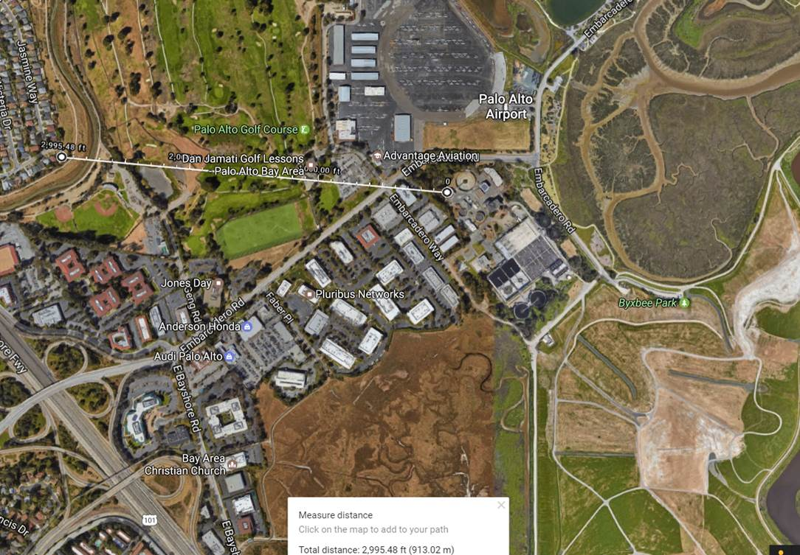

Please contact us with any questions. We have set a deadline to **collect this information by August 25th**, in order to provide the data to BAAQMD staff to update the health prioritization scores prior to adoption of the Rule (expected in September).

Regards,

Sarah A. Deslauriers, P.E.                                              Courtney Mizutani, P.E.

Carollo Engineers, Inc.                                                   Mizutani Environmental

2700 Ygnacio Valley Road, Suite 300                         5100-1B Clayton Road, PMB #129

Walnut Creek, CA 94598                                                Concord, CA 94521

Main: 925-932-1710                                                         Main: 925-686-5533

Mobile: 925-705-6404                                                     [cmizutani@sbcglobal.net](mailto:cmizutani@sbcglobal.net)

[sdeslauriers@carollo.com](mailto:sdeslauriers@carollo.com)

[www.carollo.com](http://www.carollo.com/)