OEHHA Guideline Changes
Goal: Improve Protection of Children’s Health
Major Changes:
- Age Sensitivity Factors
  - Ages 0-2: 10X
  - Ages 2-16: 3X
  - Ages 16+: 1X
- Age-Specific Exposure Variable
  - Age Groups
3rd trimester – birth birth < 2 years 2 < 9 years
2 < 16 years 16 < 30 years 16 < 70 years
  - Derived Approach for Multi-Pathway Pollutants
  - 95/80 Breathing Rate Policy for Inhalation Only Pollutants
- Fraction of Time at Home
  - Default: 0.73 – 1.0
  - Refined: 0.73 – 0.85
- Exposure Duration
  - Resident: Reduced from 70 years to 30 years
  - Worker: Reduced from 40 years to 25 years
- Spatial Averaging of Exposure Concentrations
  - Use a 400 m² grid with 5 meter intervals
Impacts Compared to Current District Procedures:
- Residential Cancer Risk
  - 40% Increase for Inhalation Only Pollutants
  - 90% - 5X Increase for Multi-Pathway Pollutants
- Worker Cancer Risk
  - Essentially No Change
- Non-Cancer Impacts
  - New TAC: caprolactam
  - REL Changes / 8-hour RELs
benzene, 1,3 butadiene, nickel, selenium
acetaldehyde, acrolein, arsenic, formaldehyde, manganese, mercury

(The following applies to residential cancer risk)
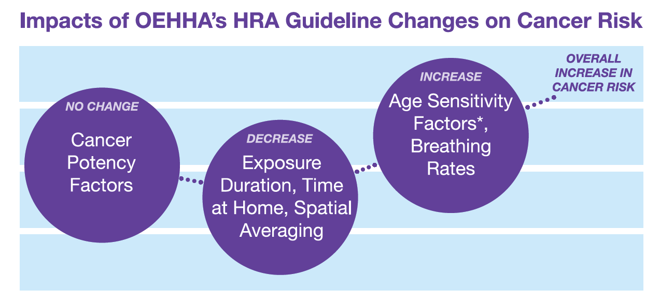

District Implementation of OEHHA Guideline Changes

- Revisions to Regulation 2, Rule 5: New Source Review of Toxic Air Contaminants (TACs)
  - Proposed Revisions
    - Update District HRA Guidelines
    - Revise Trigger Levels
    - Add Exemption for Small Engines (< 50 bhp)
    - Revise Calculation Procedure for Certain Modified Sources
  - Open Houses Held in February
  - Board Hearing Scheduled for September 21, 2016
- New Policy or Rule for Existing Facilities
  - Concept Stage
    - Apply to Sites with Cancer Risk > 10.0 in a million
    - Require TBACT for All Significant Sources
    - No Specific Risk Caps / Retain Current Thresholds
  - Workshops in 2017

